Project Report

on
AI Action Assistant

at

Infopulse Technology

Submitted in partial fulfillment of the requirement
for the award of the degree of
Bachelor of Technology
in
COMPUTER ENGINEERING
(ARTIFICIAL INTELLIGENCE)
By

Yash Sakariya (22012531054)

Under the Guidance of
Internal Guide: | External Guide:
Prof. Amit Solanki | Mr. Shilp Gohil
Semester VIII


Submitted to
Department of Computer Engineering
Faculty of Engineering & Technology
Ganpat University, Ganpat Vidyanagar-384012, Gujarat
April- 2026

U.V. PATEL COLLEGE OF ENGINEERING
Ganpat Vidyanagar-384012, Mehsana-Gandhinagar Highway,
District-Mehsana, Gujarat, INDIA



CERTIFICATE

This is to certify that Mr. Yash Sakariya student of B.Tech. Semester VIII (Computer Engineering-Artificial Intelligence) has completed his/her full semester project work titled “Title of the project” satisfactorily in partial fulfillment of the requirement of Bachelor of Technology degree of Computer Engineering(AI) of Ganpat University, Ganpat Vidyanagar in the year 2025-2026.

Prof. Amit Solanki |  | Dr. Paresh Solanki
Internal Guide |  | Head of the Department
 |  | Computer Engineering
 | Stamp
Date of Examination: 25/04/2026

ACKNOWLEDGEMENTS

I would like to express my sincere gratitude to everyone who contributed to the successful completion of this Software Requirements Specification (SRS) document.
First and foremost, I would like to thank my company guide, Mr. Shilp Gohil, for his invaluable guidance, continuous support, and practical insights throughout the course of this project. His mentorship played a crucial role in shaping the direction and execution of this work.
I would also like to express my heartfelt thanks to our Head of Department, Dr. Paresh Solanki, for his encouragement and support, which greatly motivated me during the development of this project.
I am especially grateful to my internal guide, Prof. Amit Solanki, for her guidance, constructive feedback, and constant encouragement. Her valuable suggestions significantly contributed to improving the quality of this document.
I am deeply thankful to the professors and mentors at U. V. Patel College of Engineering (UVPCE), Ganpat University, for providing the academic foundation and supportive environment necessary for this work. I would also like to thank my peers and friends for their thoughtful discussions and collaborative spirit, which helped me gain new perspectives and enhance the quality of this project.
I extend my appreciation to the authors of various references and resources that contributed to the development of this document. Their work provided valuable insights and direction for my understanding of the subject.
Best Regards, Yash Sakariya

ABSTRACT

With the increasing complexity of modern computer networks, effective monitoring and analysis have become essential for maintaining performance, reliability, and security. Traditional network scanning tools are powerful but often rely on command-line interfaces and generate complex outputs that are difficult for beginners and non-technical users to interpret.
This project presents a Ai Action Assistant designed to simplify network scanning through a user-friendly graphical interface. The system allows users to configure scans, execute them easily, and view results in structured formats such as tables and visual summaries. It provides key information including open ports, detected services, and protocol details, helping users better understand network conditions and identify potential security concerns.
The platform is especially useful for educational environments and cybersecurity training, as it promotes safe and ethical scanning within authorized networks. Overall, the system improves accessibility, usability, and understanding of network security practices through clear visualization and simplified interaction.

Index
1. INTRODUCTION 8
1.1. Project Overview 8
1.2. Project Background 8
1.3. Purpose 9
1.4. Problem Statement 11
1.5. Tools And Technologies 11
2. PROJECT SCOPE 13
2.1. Core Features 13
2.2. Objective 13
2.3. Feature and Functionality 14
2.4. User Interface and User Experience (UI/UX) 14
2.5. Security and Compliance 15
2.6. Scalability and Performance 15
2.7. Testing and Quality Assurance 16
3. LITERATURE SURVEY 17
3.1. Introduction 17
3.2. Existing Network Scanning Tools 17
3.3. Comparative Analysis of Existing Tools 18
3.4. Research Gap Identified 19
3.5. Need for Web-Based Network Scanner 20
3.6. Technical Feasibility 21
3.7. Time Schedule Feasibility 21
3.8. Operational Feasibility 23
3.9. Implementation Feasibility 23
3.10. Economic Feasibility 24
4. SOFTWARE & HARDWARE REQUIREMENTS 25
4.1. Software Requirements 25
4.2. Hardware Requirements 25
5. PROCESS MODEL 27
5.1. Introduction 27
5.2. Justification for Choosing Agile Incremental Model 27
5.3. Process Flow (Agile-Incremental Development) 28
5.4. Process Model Diagram 30
5.5. Advantages of This Model for AI Action Assistant 30
6. PROJECT PLAN 31
6.1. Project Milestones 31
6.2. Work Breakdown Structure (WBS) 31
6.3. Resource Allocation 32
6.4. Risk Management 33
7. SYSTEM DESIGN 34
7.1 Use Case Diagrams 34
7.2 Class Diagram 35
7.3 Sequence Diagram 36
7.4 Activity Diagram 37
7.5 DFD (Data Flow Diagram) 38
7.5.1 DFD 0 38
7.5.2 DFD 1 38
7.5.3 DFD 2 39
7.6 User Interface 40

8. IMPLEMENTATION DETAILS 44
8.1. Algorithm of Implementation 44
8.2. Flowchart of Implementation 45
8.3. Actual Program Code 45
9. TESTING 52
9.1. Testing Approach 52
9.2. Testing Model Used 52
9.3. Types of Testing Performed 53
9.4. Test Cases and Results 53
9.5. Test Results Summary 54
9.6. Conclusion of Testing 56
10. USER MANUAL 57
10.1. About AI Action Assistant 57
10.2. System Requirements 57
10.3. User Types 59
10.4. Login 60
10.5. User Portal Guide 60
10.6. Network Scanning and Analysis Features 62
10.7. Troubleshooting 62
11. CONCLUSION & FUTURE WORK 64
11.1. Conclusion 64
11.2. Future Work 64
12. ANNEXURE 65
12.1. Glossary of Terms and Abbreviations 65
12.2. References 66
12.3. About Tools and Technology 67
12.4. About The Organization 69
12.5. About College 72

LIST OF FIGURES

Figure 8-1 Use Case Diagram 26

Figure 8-2 Class Diagram 27

Figure 8-3 Sequence Diagram 28

Figure 8-4 Activity Diagram 29

Figure 8-5 DFD-0 30

Figure 8-6 DFD-1 30

Figure 8-7 DFD-2 31

Figure 8-8 Login Page 32

Figure 8-9 Sign Up Page 33

Figure 8-10 Dashboard 34

Figure 8-11 Result Page 35

Figure 8-12 Host Discovery Page 36

Figure 8-13 Log Analyzer Page 37

Figure 8-14 Port Scan Page 38

Figure 9-1 Flowchart 41

LIST OF TABLES

Table 3-1 Comparative Analysis of Existing Tools 9

Table 7-1 Project Milestones 22

Table 7-2 Risk Management 24

Table 10-1 Test Cases 54

Table 13-1 Glossary of Terms and Abbreviation 68

INTRODUCTION

Project Overview

The AI Action Assistant is a production-grade agentic AI system designed to execute real-world tasks through natural language commands via a web-based interface. Unlike conventional AI chatbots that merely generate text responses, this system bridges the gap between language understanding and actual task execution by integrating with multiple external services such as Gmail, Google Calendar, live news, weather, and web search APIs.
The primary objective of the system is to enforce a strict architectural separation where the Large Language Model (LLM) is responsible solely for reasoning, intent classification, and argument extraction, while all real-world actions are executed exclusively by Python code. This design principle eliminates the risk of the LLM hallucinating or pretending to perform actions that are never actually carried out.
The system operates through a 7-step chat processing pipeline that handles user input, detects intent, validates extracted data through an anti-hallucination layer, collects any missing information through multi-turn conversation, presents a confirmation preview for irreversible actions such as sending emails or scheduling calendar events, executes the action via the appropriate API, and finally formats the response for the user.
A 3-tier LLM model architecture is implemented to distribute workload intelligently across different models based on task complexity, optimizing both cost and performance. The system also incorporates a Retrieval Augmented Generation (RAG) pipeline powered by ChromaDB and Sentence Transformers, enabling the assistant to answer queries from a custom knowledge base.
Additional capabilities include voice input through the Groq Whisper API, voice output via the browser's Web Speech Synthesis API, document summarization, JWT-based user authentication, persistent conversation memory, and an MCP (Model Context Protocol) server that allows integration with external AI tools
such as Claude Desktop and Cursor IDE. The system is deployed using Docker on the Railway cloud platform, ensuring scalability and production-readiness.

Project Background

The rapid advancement of Large Language Models (LLMs) such as GPT-4, LLaMA 3, and Gemini has led to a proliferation of AI-powered chatbot applications. However, the majority of these applications function as passive text-generation interfaces — they receive a user query, forward it to an LLM, and display the raw textual response. They cannot execute real-world actions such as sending emails, scheduling calendar events, or fetching live data. When users instruct such chatbots to perform tasks, the AI merely generates a plausible-sounding confirmation without any actual execution.
This limitation is compounded by the problem of hallucination, where LLMs fabricate plausible but incorrect information. In action-execution contexts, hallucination becomes a critical safety concern — the model might fabricate email addresses, invent dates the user never specified, or generate email bodies containing placeholder text. Without robust validation, such hallucinated data could propagate into real-world systems and cause unintended consequences.

The concept of Agentic AI has emerged to address these limitations. Unlike traditional chatbots, agentic AI systems are designed to reason, plan, validate, and execute real tasks by interfacing with external APIs and services. Several frameworks such as LangChain and OpenAI's function-calling mechanism provide infrastructure for connecting LLMs to tools. However, these approaches typically delegate tool invocation to the LLM itself, which may invoke tools with hallucinated parameters. Additionally, most existing solutions lack a human-in-the-loop confirmation mechanism for irreversible actions.

Anthropic's Model Context Protocol (MCP), introduced in late 2024, provides a standardized open protocol for connecting AI models with external tools and data sources. While MCP addresses interoperability, it does not inherently solve hallucination or confirmation challenges — these remain the responsibility of the implementing system.
Another practical challenge is cost efficiency. Cloud-hosted LLM APIs impose daily token quotas on free tiers. Routing every request through a single high-capacity model — from simple weather formatting to complex intent classification — leads to rapid quota exhaustion and suboptimal performance.
Against this backdrop, the present project was developed to build a production-grade AI assistant that enforces a strict separation between LLM reasoning and Python-based action execution. The

system evolved through nine complete architectural rebuilds — from early versions that allowed the LLM to "pretend" to execute actions, through iterations that introduced multi-turn state management, anti-hallucination validators, and confirmation gates, to the final production-hardened system with JWT authentication, rate limiting, database persistence, Docker deployment, and MCP protocol integration.

Purpose

The purpose of this project is to design and develop a production-grade Agentic AI system that bridges the gap between conversational AI and real-world task execution. Unlike conventional chatbot applications that are limited to generating textual responses, the AI Action Assistant is built to interpret natural language commands, plan appropriate actions, validate all parameters against hallucination, and execute tasks through authenticated external APIs — all within a single unified conversational interface.
Specifically, this project aims to demonstrate that an AI assistant can reliably send emails via the Gmail API, schedule events via the Google Calendar API, fetch live weather and news data, perform web searches, summarize uploaded documents, and answer knowledge-base queries using Retrieval Augmented Generation (RAG) — while ensuring that no action is executed with fabricated or unverified data. The system enforces a strict architectural principle: the LLM handles reasoning and language generation only, while Python code performs all real-world execution, with a mandatory confirmation gate for irreversible actions.
Furthermore, the project addresses the practical challenge of LLM cost management by implementing a 3-tier model routing architecture that distributes workload across models of varying capacity — assigning complex reasoning tasks to high-capability models and simple formatting tasks to lightweight, cost-efficient models. The system also exposes a Model Context Protocol (MCP) server, enabling seamless integration with external AI tools such as Claude Desktop and Cursor IDE, thereby extending the assistant's functionality beyond its own web interface. Through this project, the aim is to establish a reusable architectural pattern for building trustworthy, action-capable AI systems suitable for real-world deployment.

Problem Statement

Existing AI chatbot applications function as simple wrappers around LLM APIs — they receive user queries and return text responses without the ability to execute real-world actions. When users request tasks such as sending emails or scheduling meetings, these systems generate fictional confirmations without any actual execution.
The key problems identified are:
- No Action Execution: Current chatbots cannot interact with external services (Gmail, Google Calendar, Weather APIs) to perform real tasks on behalf of the user.
- Hallucination in Critical Data: LLMs frequently fabricate email addresses, dates, and other sensitive parameters, which can lead to incorrect or unintended actions if left unvalidated.
- No User Confirmation: Actions are executed — or pretended — without providing a preview or requiring explicit user approval, creating risks for irreversible operations.
- Single-Model Inefficiency: Routing all tasks through a single LLM model leads to rapid token quota exhaustion and suboptimal performance, as simple formatting tasks consume the same resources as complex reasoning.
- No Knowledge Base Integration: Conventional chatbots cannot answer queries grounded in custom document collections using techniques such as Retrieval Augmented Generation.
- Lack of Interoperability: Most chatbot systems are locked to their own interface and cannot be accessed from other AI tools or development environments through standardized protocols.
.

Tools And Technologies

Python 3.11 — Selected for its mature AI/ML ecosystem, asynchronous support, and extensive API client libraries.
Large Language Models (LLMs):
- Groq Cloud API — Cloud-hosted LLM inference with ultra-low latency.
- LLaMA 3.3 70B Versatile — Used for email drafting, document summarization, and calendar event descriptions.
- LLaMA 3.1 8B Instant — Used for weather/news formatting, general conversation, and memory compression.
- GPT-OSS 120B — Used for intent classification, action planning, and RAG answer synthesis.

Backend Framework:
- FastAPI — High-performance asynchronous Python web framework with automatic OpenAPI documentation.
- Uvicorn — ASGI server for serving the FastAPI application.
Database:
- SQLite — Lightweight relational database used for local development.
- PostgreSQL — Production database used for cloud deployment on Railway.
- SQLAlchemy ORM — Database-agnostic Object Relational Mapper for Python.
Vector Database and Embeddings:
- ChromaDB — Persistent vector database for storing and querying document embeddings.
- Sentence Transformers (all-MiniLM-L6-v2) — Pre-trained model for generating 384-dimensional text embeddings.
Authentication and Security:
- JWT (JSON Web Tokens) — Stateless token-based authentication using the python-jose library.
- bcrypt — Password hashing with automatic salt generation.
- Google OAuth2 — Per-user authentication for Gmail and Google Calendar access.
External API Integrations:
- Gmail API — For sending real emails via OAuth2 authentication.
- Google Calendar API — For creating calendar events with custom reminders.
- NewsAPI — For fetching real-time news headlines by topic or category.
- OpenWeatherMap API — For retrieving current weather data for any city worldwide.
- DuckDuckGo Search — For web search without requiring an API key.
- Wikipedia API — Fallback search strategy for reliable information retrieval.
Speech Processing:
- Groq Whisper API (whisper-large-v3-turbo) — For speech-to-text transcription.
- Browser Web Speech Synthesis API — For client-side text-to-speech output.
Document Processing:
- pypdf — For extracting text from PDF files.
- python-docx — For extracting text from DOCX files.
- pandas + openpyxl — For processing Excel (XLSX) files.
- BeautifulSoup4 — For parsing HTML content from web pages.
Protocol:
- Model Context Protocol (MCP) via FastMCP — Standardized protocol for exposing AI tools to external clients such as Claude Desktop and Cursor IDE.
Frontend:
- HTML5, CSS3, JavaScript — Vanilla stack with no frontend framework or build tools.
- Google Fonts (Geist Mono, DM Sans) — Custom typography for a terminal-inspired dark theme.
Deployment:
- Docker — Containerized deployment with CPU-optimized PyTorch build.
- Railway — Cloud platform with automatic GitHub integration and PostgreSQL provisioning.

PROJECT SCOPE

Core Features

The system provides the following core features to facilitate efficient network scanning and analysis:
- Email Sending - Send real emails via Gmail API with auto-drafting and user confirmation.
- Calendar Scheduling - Create Google Calendar events through natural language commands.
- Weather Data - Fetch real-time weather for any city via OpenWeatherMap API.
- News Retrieval - Get latest headlines by topic using NewsAPI.
- Web Search - Search the internet via DuckDuckGo with Wikipedia fallback.
- Document Summarization - Summarize uploaded PDF, DOCX, XLSX, and TXT files.
- RAG Knowledge Base - Answer queries from custom documents using vector search.
- Voice Support - Speech-to-text (Groq Whisper) and text-to-speech (Web Speech API).
- Anti-Hallucination Validation - Validates all critical data before execution.
- User Authentication - JWT-based login with bcrypt password hashing.
- MCP Protocol - 9 tools exposed for integration with Claude Desktop and Cursor IDE.

Objective
The primary objective of this project is to design and develop a production-grade AI assistant that can execute real-world tasks through natural language commands while preventing LLM hallucination in critical operations.
The specific objectives are:
- Build a 7-step chat processing pipeline that separates LLM reasoning from Python-based action execution.
- Implement an anti-hallucination validation layer to prevent fabricated email addresses, dates, and other critical data.
- Integrate with external services including Gmail API, Google Calendar API, NewsAPI, OpenWeatherMap, and DuckDuckGo for real task execution.
- Design a 3-tier LLM model routing architecture to optimize cost and performance across tasks of varying complexity.
- Develop a RAG pipeline using ChromaDB and Sentence Transformers for knowledge base queries.
- Implement a confirmation-gate mechanism for irreversible actions such as sending emails and creating calendar events.
- Build a secure authentication system using JWT and bcrypt with per-user Google OAuth2 support.
- Expose an MCP server for interoperability with external AI tools such as Claude Desktop and Cursor IDE.
- Deploy the system using Docker on Railway cloud platform for production readiness.

Feature and Functionality

- Natural Language Processing - Interprets user commands and extracts intent with structured parameters.
- Email & Calendar Execution - Sends real emails and creates calendar events via Google APIs with mandatory user confirmation.
- Live Data Retrieval - Fetches real-time weather, news, and web search results from external APIs.
- Document Summarization - Extracts and summarizes content from uploaded PDF, DOCX, XLSX, and TXT files.
- RAG Knowledge Base - Answers queries from custom documents using vector similarity search.
- Anti-Hallucination Validation - Verifies all critical data against actual user input before execution.
- 3-Tier LLM Routing - Distributes tasks across models of varying capacity for cost optimization.
- Voice Input/Output — Speech-to-text via Whisper and text-to-speech via Web Speech API.
- Conversation Memory — Maintains context across multi-turn conversations with LLM compression.
- MCP Interoperability — 9 tools accessible from Claude Desktop and Cursor IDE.

User Interface and User Experience (UI/UX)

AI Action Assistant features a clean, modern, dark-themed web interface built with vanilla HTML, CSS, and JavaScript — requiring no frontend framework or build tools.

Login & Signup Pages: Centered card layouts with minimal form fields, error banners, and automatic redirection to the dashboard upon successful authentication.

Dashboard (Main Chat Interface): A two-column layout with a fixed sidebar (260px) and a flexible chat area. The sidebar contains a service selector with six toggleable chips (Weather, News, Search, Email, Calendar, Summarize), a scrollable chat history list, Google account connection status, and a system status indicator. The chat area displays message bubbles with distinct AI and user avatars, status badges (SUCCESS, AWAITING, PENDING,

ERROR), inline Confirm/Cancel buttons for pending actions, and a copy-to-clipboard option on every message.

Input Area: Features an auto-resizing textarea, a file attachment button supporting drag-and-drop, a microphone button for voice input, quick-action toolbar chips, and a send button — all within a rounded container with focus glow effect.

Responsive Design: The sidebar is hidden on screens narrower than 680px, ensuring usability on mobile devices. The input area remains full-width across all screen sizes.

Typography & Theme: Uses Geist Mono for labels, badges, and code elements, and DM Sans for body text. The dark theme uses a #0a0a0a background with #10a37f (green) as the accent color, creating a terminal-inspired aesthetic.

User Feedback: Typing indicators with animated dots, status badges per message, and real-time visual feedback for file uploads, voice recording, and action confirmations ensure a smooth and responsive user experience.
.

Security and Compliance

- JWT Authentication — All API endpoints require a valid JSON Web Token. Tokens expire after 72 hours.
- bcrypt Password Hashing — Passwords are stored as one-way hashes with auto-generated salts.
- OAuth2 State Tokens — CSRF protection during Google OAuth flow using in-memory state tokens.
- Anti-Hallucination Layer — Prevents LLM-fabricated data from reaching external APIs by validating all parameters against actual user input.
- Confirmation Gate — Irreversible actions (email, calendar) require explicit user approval before execution.
- Rate Limiting — 30 requests per session per 60-second window to prevent abuse.
- File Upload Restrictions — Maximum 10MB file size with allowed extensions limited to PDF, DOCX, XLSX, and TXT.
- CORS Policy — Restricted to known origins only.
- Environment Variable Security — All API keys and secrets stored in .env file, excluded from version control via .gitignore.
- Input Sanitization — All user inputs are stripped and validated before processing.

Scalability and Performance

- Asynchronous Backend — FastAPI with Uvicorn handles concurrent requests without blocking.
- 3-Tier LLM Routing — Prevents token exhaustion by distributing tasks across three models.
- Docker Deployment — CPU-optimized build for lightweight, portable containerization.
- Railway Cloud — Auto-scaling infrastructure with GitHub-based CI/CD.
- In-Memory Caching — Thread-safe session caching reduces database queries.
- Memory Compression — LLM summarization of older messages prevents unbounded growth.
- HNSW Indexing — Fast vector search in ChromaDB for RAG retrieval.

Testing and Quality Assurance

- Terminal Chat Client — Interactive terminal interface (test_terminal.py) for end-to-end testing of all features and multi-turn conversations.
- MCP Tool Test Suite — Automated tests (test_mcp.py) covering all 9 MCP tools individually and collectively.
- MCP Inspector — Browser-based UI at localhost:5173 for visual interaction and testing of all tools.
- API Documentation — Auto-generated Swagger UI at /docs for manual API endpoint testing.
- Health Check Endpoint — /health endpoint monitors system status and service availability.
- Input Validation — Pydantic models enforce strict type-checking on all API requests and responses.
- Anti-Hallucination Testing — Validators independently verified to reject fabricated emails, past dates, and placeholder content.
- Iterative Rebuilds — Nine complete architectural rebuilds ensured fundamental design flaws were identified and corrected before production deployment.

LITERATURE SURVEY

Introduction

This literature survey examines existing research across key domains relevant to the AI Action Assistant — Large Language Models, Agentic AI, Retrieval Augmented Generation, anti-hallucination techniques, and AI interoperability protocols.
Transformer-based LLMs like GPT-4 and LLaMA 3 have enabled advanced natural language understanding, but remain limited to text generation without real-world task execution. Frameworks such as LangChain and AutoGPT attempt to connect LLMs to tools, but delegate execution control to the model — risking hallucinated parameters.
RAG (Lewis et al., 2020) addresses knowledge limitations by grounding LLM responses in external documents through vector search. LLM hallucination - generating plausible but incorrect data - poses critical risks in action-execution contexts. Anthropic's Model Context Protocol (MCP) provides a standardized way to connect AI models with external tools across platforms.
This survey reviews these areas to contextualize the design decisions of the proposed system.
.

Existing Network Scanning Tools

Several AI assistant systems exist in the market, each with varying capabilities and limitations:

ChatGPT (OpenAI): A widely used conversational AI that generates text responses. Supports function-calling for tool integration but relies on the LLM to decide tool invocation, with no built-in hallucination validation for action parameters.

Google Assistant / Siri / Alexa: Voice-based assistants with predefined skill sets. Limited to manufacturer-defined actions and lack customizability or open-source extensibility.

LangChain Agents: An open-source framework for building LLM-powered agents with tool access. Provides flexible architecture but delegates execution control to the LLM, introducing risks of hallucinated tool parameters.

Claude with MCP (Anthropic): Supports the Model Context Protocol for connecting to external tools. Provides interoperability but does not include built-in anti-hallucination validation or confirmation gates for critical actions.

Key Gaps Identified: Most existing tools either lack real-world action execution capability, delegate unsafe control to the LLM, or do not implement validation and user confirmation for irreversible operations. The AI Action Assistant addresses these gaps through its 7-step pipeline, anti-hallucination validators, and mandatory confirmation gate architecture.
.

Comparative Analysis of Existing Tools
A comparative analysis has been conducted to evaluate the limitations of existing network scanning tools in contrast with the capabilities of the proposed system. This comparison highlights key differences in terms of usability, accessibility, functionality, and user management.

Parameter | Existing Tools | Proposed System
Interface | Primarily command-line based, requiring users to input manual commands. | Web-based graphical interface with interactive components and cyberpunk design.
Ease of Use | Requires technical expertise and familiarity with command-line operations. | User-friendly interface designed for both technical and non-technical users.
Result  Visualization | Provides raw, unstructured  output that can be difficult to interpret. | Displays structured results using dashboards tables, and graphical visualizations.
Accessibility | Limited to local systems where the tool is installed. | Accessible via web browsers from multiple devices and locations.
User  Management | Does not support multi-user environments or access control mechanisms. | Implements user authentication and role-based access control for secure usage.

Table 3-1 Comparative Analysis of Existing Tools

The analysis clearly indicates that while existing tools are powerful in terms of functionality, they lack usability, accessibility, and centralized management features. These limitations make them less suitable for beginners, students, and collaborative environments.
In contrast, the proposed system overcomes these challenges by integrating a web-based interface, enhanced visualization, and secure user management. This not only improves usability but also expands the applicability of network scanning tools in academic, training, and controlled security assessment scenarios.

Research Gap Identified

Based on the literature survey and comparative analysis, the following research gaps were identified:

- No LLM-Execution Separation: Existing systems allow the LLM to directly invoke tools and APIs, creating a trust problem where hallucinated parameters can propagate into real-world actions.

- Absence of Anti-Hallucination Validation: No existing open-source AI assistant implements a dedicated validation layer that verifies LLM-extracted data (emails, dates) against actual user input before execution.

- Missing Confirmation Mechanism: Most systems execute actions immediately without providing a preview or requiring explicit user approval for irreversible operations.

- Single-Model Bottleneck: Existing implementations route all tasks through a single LLM, leading to token quota exhaustion and suboptimal cost-performance tradeoffs.

- No Standardized Interoperability: Few AI assistants expose their capabilities through open protocols like MCP, limiting their usability to a single interface.

- Limited Multi-Service Integration: Most tools support only one or two external services rather than providing a unified interface for email, calendar, weather, news, search, and document processing.

The AI Action Assistant addresses all of these gaps through its 7-step pipeline architecture, anti-hallucination validators, confirmation gate, 3-tier model routing, and MCP protocol support

Need for Web-Based Network Scanner

Despite the widespread adoption of AI chatbots, users still lack a reliable tool that can execute real-world tasks safely through natural language. Current AI assistants either generate text-only responses or delegate tool execution to the LLM without validation — both approaches fail to meet production-grade safety requirements.
There is a clear need for a system that:

- Executes real actions (sending emails, scheduling events, fetching live data) rather than generating fictional confirmations.

- Validates all LLM-generated parameters against actual user input to prevent hallucination from reaching external APIs.

- Requires explicit user confirmation before performing irreversible operations.

- Provides a unified conversational interface for multiple services instead of requiring separate tools for each task.

- Optimizes LLM usage across tasks of varying complexity to manage cost and performance within free-tier API constraints.

- Supports interoperability with external AI platforms through standardized protocols.

The AI Action Assistant fulfills this need by providing a production-ready, open-source platform that combines natural language understanding with safe, validated, and user-confirmed real-world task execution.

Technical Feasibility

The AI Action Assistant is technically feasible based on the following factors:

- LLM Availability: Groq Cloud provides free-tier access to multiple LLM models (LLaMA 3.3 70B, LLaMA 3.1 8B) with sufficient daily token budgets for a production system.

- API Accessibility: Gmail API, Google Calendar API, NewsAPI, and OpenWeatherMap all offer free tiers with well-documented REST interfaces and official Python client libraries.

- Framework Maturity: Python 3.11, FastAPI, SQLAlchemy, and ChromaDB are production-proven, actively maintained, and widely adopted in the industry.

- Embedding Models: Sentence Transformers (all-MiniLM-L6-v2) runs efficiently on CPU without requiring GPU hardware, making RAG feasible on standard development machines.

- Deployment Infrastructure: Docker and Railway provide containerized cloud deployment with automatic scaling, PostgreSQL provisioning, and GitHub-based CI/CD at minimal cost.

- Protocol Support: The FastMCP library provides a ready-to-use implementation of the Model Context Protocol, enabling straightforward interoperability with Claude Desktop and Cursor IDE.

- Frontend Simplicity: Vanilla HTML/CSS/JS eliminates the need for complex build pipelines, reducing development overhead while maintaining full UI control.

All technologies used are open-source, well-documented, and compatible with each other — confirming the technical feasibility of the proposed system.

Time Schedule Feasibility

The project went through 9 complete architectural rebuilds during development, each addressing a fundamental design flaw. Despite the iterative nature, the modular architecture allowed individual components to be rebuilt independently without affecting the entire system — keeping the project within the feasible timeline.

The project was developed over the course of the 8th semester (approximately 4 - 5months) following an iterative development approach. The time schedule was divided into the following phases:

Phase | Activity | Duration
Phase 1 | Requirement Analysis & Research | 2 Weeks
Phase 2 | Backend Architecture & Chat Engine | 3 Weeks
Phase 3 | LLM Integration & 3-Tier Routing | 2 Weeks
Phase 4 | External API Integrations (Email, Calendar, Weather, News, Search) | 3 Weeks
Phase 5 | Anti-Hallucination Validation Layer | 2 Weeks
Phase 6 | RAG Pipeline & Vector Database | 2 Weeks
Phase 7 | Frontend Development (5 HTML Pages) | 2 Weeks
Phase 8 | MCP Server Implementation | 1 Week
Phase 9 | Testing, Debugging & Iterative Rebuilds | 2 Weeks
Phase 10 | Docker Deployment & Documentation | 1 Week

Operational Feasibility

The AI Action Assistant is operationally feasible and ready for real-world usage based on the following considerations:

- Ease of Use: Users interact through a simple chat interface using natural language - no technical knowledge is required to send emails, schedule events, or fetch data.

- Minimal Setup: The system requires only API keys configured in a .env file. A single command (python run_api.py) starts the entire application.

- Web-Based Access: No software installation needed for end users — the system is accessible through any modern web browser.

- Low Infrastructure Cost: The system operates entirely on free-tier APIs (Groq, NewsAPI, OpenWeatherMap) and can be deployed on Railway's free or low-cost plan.

- Self-Contained Deployment: Docker containerization ensures the system runs consistently across any environment without dependency conflicts.

- User Safety: The confirmation gate ensures users always review and approve irreversible actions before execution, reducing operational risk.

- Maintainability: Modular architecture with clearly separated components (backend, core, services, frontend) allows individual modules to be updated or replaced independently.

- Multi-Platform Access: Beyond the web UI, the system is accessible via terminal client and any MCP-compatible AI tool, providing operational flexibility.

Implementation Feasibility

The AI Action Assistant has been fully implemented and deployed, confirming its implementation feasibility:

- Language & Framework: Python 3.11 with FastAPI provides a well-supported, high-performance foundation with extensive community resources and documentation.

- LLM Access: Groq Cloud API offers free-tier access with sufficient token budgets. The 3-tier routing and automatic fallback mechanism ensures uninterrupted service even when one key hits its daily limit.

- API Libraries: Official Python client libraries are available for all integrated services - Gmail, Google Calendar, NewsAPI, OpenWeatherMap, ChromaDB, and DuckDuckGo.

- Database: SQLAlchemy ORM enables seamless switching between SQLite (development) and PostgreSQL (production) with no code changes.

- RAG Pipeline: Sentence Transformers runs on CPU without GPU dependency, and ChromaDB provides persistent local vector storage — both require minimal infrastructure.

- Deployment: Docker and Railway simplify the build-deploy pipeline. The Dockerfile is optimized for CPU-only PyTorch, keeping image size manageable (~800MB).

- Proven Through Iteration: The system underwent 9 complete rebuilds, with each iteration resolving a specific architectural flaw — demonstrating that all design challenges were solvable within the chosen technology stack.

Economic Feasibility

The AI Action Assistant is designed to operate at minimal to zero cost using freely available resources:

Resource | Cost
Groq Cloud API (LLM inference) | Free tier
NewsAPI | Free tier (100 requests/day)
OpenWeatherMap API | Free tier (1000 calls/day)
Gmail & Google Calendar API | Free (OAuth2)
DuckDuckGo Search | Free (no API key required)
ChromaDB & Sentence Transformers | Free, open-source
Python, FastAPI, SQLAlchemy | Free, open-source
SQLite Database | Free, built-in
Railway Deployment | Free/low-cost starter plan
Docker | Free, open-source
GitHub | Free

- No paid software licenses are required — the entire stack is open-source.

- No GPU hardware is needed — all models run on CPU or via cloud API.

- 3-tier LLM routing maximizes free-tier token budgets by assigning simple tasks to lightweight models.

- Total development and operational cost: effectively zero for academic and personal use.

SOFTWARE & HARDWARE REQUIREMENTS

This section outlines the software and hardware requirements necessary for the development, deployment, and efficient operation. These requirements ensure that the system performs reliably and supports all intended functionalities.

Software Requirements

Operating System: Windows 10/11, Linux (Ubuntu 20.04+), or macOS. The system is platform-independent due to Python and Docker-based deployment.

Programming Language: Python 3.10 or above is required for backend development, LLM integration, and all service modules.

Backend Framework: FastAPI 0.110+ serves as the web framework, providing asynchronous request handling and automatic Swagger API documentation. Uvicorn is used as the ASGI server for running the application.

Database: SQLite is used for local development with zero configuration. PostgreSQL is used for production deployment on Railway, connected via the DATABASE_URL environment variable. SQLAlchemy 2.0+ provides the ORM layer.

LLM API: A Groq Cloud API account with at least one valid API key is required. Up to three keys can be configured for the 3-tier model routing architecture.

Vector Database and Embeddings: ChromaDB 0.5+ is used for persistent vector storage. Sentence Transformers with the all-MiniLM-L6-v2 model generates 384-dimensional embeddings for the RAG pipeline. Both run on CPU without GPU dependency.

Google APIs: A Google Cloud Console project with Gmail API and Google Calendar API enabled is required. OAuth2 credentials (credentials.json) must be generated and the token.pickle file created via the provided setup script.

External APIs: A NewsAPI key (from newsapi.org) for news retrieval and an OpenWeatherMap API key (from openweathermap.org) for weather data are required. DuckDuckGo and Wikipedia require no API keys.

Web Browser: Any modern browser (Chrome, Firefox, Edge) is required for accessing the web-based dashboard interface.

Development and Deployment Tools: Git for version control, Docker for containerization, and VS Code or Cursor IDE for development. pip manages all Python package installations via requirements.txt.

Hardware Requirements

The system does not require specialized hardware and can operate efficiently on standard computing devices. The minimum and recommended hardware specifications are as follows:
For Development (Minimum):

- Processor: Intel Core i5 / AMD Ryzen 5 or equivalent
- RAM: 8 GB (16 GB recommended for running ChromaDB and Sentence Transformers simultaneously)
- Storage: 2 GB free disk space for project files, dependencies, and vector database
- Network: Stable internet connection for accessing LLM APIs, Google APIs, and external services
- GPU: Not required — all models and embeddings run on CPU

For Production Deployment (Railway):

- Server: Cloud-based container instance provisioned automatically by Railway
- RAM: Minimum 512 MB (1 GB recommended for stable operation with vector search)
- Storage: Managed by Railway with PostgreSQL database provisioning
- Network: Public HTTPS endpoint provided by Railway for web access

For End Users (Client-Side):

- Device: Any desktop, laptop, or mobile device with a modern web browser
- Browser: Chrome, Firefox, or Edge (latest version)
- Microphone: Required only for voice input feature
- Speaker: Required only for text-to-speech output

PROCESS MODEL

Introduction
A process model defines the structured approach followed during the software development lifecycle. It provides a framework for organizing tasks, managing progress, and ensuring systematic delivery of the final product.
The AI Action Assistant was developed using the Iterative and Incremental Development Model. This model was chosen because the project required continuous refinement — the system went through 9 complete architectural rebuilds, with each iteration addressing a specific design flaw discovered during development and testing.
In this model, the system is built in small increments where each cycle involves planning, development, testing, and evaluation. New features are added incrementally while existing components are refined based on feedback and testing results. This approach allowed:
- Early detection of fundamental design issues (e.g., LLM pretending to execute actions, hallucinated parameters reaching APIs)
- Independent rebuilding of individual modules without affecting the entire system
- Gradual integration of services — starting with basic chat, then adding email, calendar, weather, news, search, RAG, and MCP in successive iterations
- Continuous testing and validation after each increment to ensure stability before adding new functionality
The iterative approach was particularly suitable for this project because AI system behavior is inherently unpredictable — issues such as hallucination patterns and edge cases in intent classification could only be identified through repeated testing and refinement cycles.

Justification for Choosing Agile Incremental Model
The Agile Incremental Model was chosen for this project due to the following reasons:
- Unpredictable LLM Behavior: AI systems produce non-deterministic outputs. Issues such as hallucination, incorrect intent classification, and edge cases could only be discovered through iterative testing — making a linear model like Waterfall unsuitable.

- Evolving Requirements: As development progressed, new requirements emerged (e.g., anti-hallucination validation, confirmation gate, 3-tier model routing) that were not fully anticipated during initial planning.
- Modular Architecture: The system's layered design (backend, core, services, frontend) allowed individual components to be developed, tested, and rebuilt independently in each iteration.
- 9 Architectural Rebuilds: The project underwent 9 complete rebuilds — each addressing a specific flaw. The Agile model naturally accommodated these cycles without disrupting the overall timeline.
- Continuous Integration of Services: Services were added one at a time (weather → news → email → calendar → RAG → MCP), with each increment tested and stabilized before the next was introduced.
- Early and Frequent Feedback: Each increment produced a working version of the system, allowing immediate testing and validation rather than waiting until the entire system was complete.
- Risk Mitigation: By delivering working increments early, critical risks (LLM hallucination, API failures, token exhaustion) were identified and resolved in the early stages of development.
The Agile Incremental Model aligned well with the exploratory and iterative nature of building an agentic AI system.

Process Flow (Agile-Incremental Development)

The The development of the AI Action Assistant followed an iterative cycle across 9 increments:

Increment 1–3: Core Chat Engine

- Built the basic chat interface with LLM integration
- Identified flaw: LLM was "pretending" to execute actions instead of actually performing them
- Resolution: Established strict separation between LLM reasoning and Python execution

Increment 4–5: Multi-Turn State Management

- Added email and calendar services with multi-turn field collection
- Identified flaw: System lost context between conversation turns
- Resolution: Implemented session state management with pending action scratchpad

Increment 6–7: Anti-Hallucination Layer

- Integrated validation for email addresses and calendar dates
- Identified flaw: LLM fabricated email addresses and dates not present in user input
- Resolution: Built regex-based validation against actual user messages and future-date enforcement

Increment 8: Confirmation Gate

- Added preview and confirmation mechanism for irreversible actions
- Identified flaw: Actions were executing without user approval
- Resolution: Implemented awaiting_confirmation state with explicit confirm/cancel flow

Increment 9: Production Hardening

- Added JWT authentication, rate limiting, database persistence, MCP server, Docker deployment, and RAG pipeline
- Final stabilization, testing, and deployment to Railway

Each increment followed this cycle:

- Plan — Define features and identify requirements for the increment
- Develop — Implement new modules and integrate with existing components
- Test — Validate functionality through terminal client, API testing, and MCP inspector
- Evaluate — Identify flaws and document improvements for the next iteration
- Refine — Rebuild or modify components based on evaluation results

Process Model Diagram
The Agile Incremental Development Model used in this project follows a repeating cycle of five phases: Plan, Develop, Test, Evaluate, and Refine. Each increment passes through this cycle before proceeding to the next.
The cycle begins with the Plan phase, where features and requirements for the current increment are defined. This is followed by the Develop phase, where new modules are implemented and integrated with existing components. The Test phase validates functionality through terminal testing, API testing, and MCP inspector. In the Evaluate phase, flaws, bugs, and design issues are identified. Finally, the Refine phase involves rebuilding or modifying components based on findings. After refinement, the cycle returns to the Plan phase for the next increment.
This cycle was repeated across nine increments: Increments 1 to 3 focused on the Core Chat Engine, Increments 4 to 5 addressed State Management, Increments 6 to 7 built the Anti-Hallucination Layer, Increment 8 implemented the Confirmation Gate, and Increment 9 completed Production Hardening with authentication, deployment, and MCP integration.
Each increment produced a working version of the system, and the iterative nature
ensured that design flaws were detected and resolved early before new features were added.

Advantages of This Model for AI Action Assistant

- The Handles Unpredictable AI Behavior: LLM outputs are non-deterministic. The iterative model allowed discovering and fixing issues like hallucination and incorrect intent classification through repeated testing cycles.

- Supports Incremental Service Integration: Services (weather, news, email, calendar, search, RAG, MCP) were added one at a time, with each tested and stabilized before introducing the next.

- Accommodates Design Changes: Major architectural decisions such as the anti-hallucination layer and confirmation gate emerged during development. The Agile model naturally accommodated these changes without disrupting progress.

- Early Risk Detection: Critical issues like LLM fabricating email addresses and actions executing without user approval were identified early through iterative testing rather than at the end of development.

- Modular Rebuilding: The 9 architectural rebuilds were possible because individual modules could be redesigned independently without rewriting the entire system.

- Continuous Working Product: Each increment delivered a functional version of the system, allowing validation at every stage and ensuring the final product was stable and thoroughly tested.

- Flexible Timeline Management: When an increment required more time due to unexpected issues, subsequent increments could be adjusted without affecting the overall project deadline.

PROJECT PLAN

Project Milestones
The project development was organized into the following key milestones:
Milestone 1: Requirement Analysis and Research (Week 1–2) Study of existing AI assistants, identification of research gaps, selection of technology stack, and project planning.
Milestone 2: Core Chat Engine Development (Week 3–5) Implementation of the FastAPI backend, basic LLM integration via Groq API, and the initial 7-step chat processing pipeline.
Milestone 3: External Service Integration (Week 6–8) Integration of Gmail API, Google Calendar API, OpenWeatherMap, NewsAPI, and DuckDuckGo web search with individual service modules.
Milestone 4: Anti-Hallucination and Validation Layer (Week 9–10) Development of email address validation, date parsing with future enforcement, placeholder detection, and the confirmation gate architecture.
Milestone 5: RAG Pipeline and Knowledge Base (Week 11–12) Implementation of ChromaDB vector database, Sentence Transformer embeddings, document ingestion, and LLM-based answer synthesis.
Milestone 6: 3-Tier LLM Routing (Week 12–13) Design and implementation of multi-model routing across Primary, Medium, and Light tiers with automatic fallback mechanism.
Milestone 7: Frontend Development (Week 13–14) Development of five self-contained HTML pages — Login, Signup, Dashboard, Profile, and About — with dark theme and responsive design.
Milestone 8: MCP Server and Voice Features (Week 15–16) Implementation of 9 MCP tools, 3 resources, 7 prompts, Groq Whisper STT integration, and Web Speech TTS.
Milestone 9: Authentication and Database (Week 16–17) JWT-based authentication, bcrypt password hashing, per-user Google OAuth2, and SQLAlchemy ORM with SQLite/PostgreSQL support.
Milestone 10: Deployment, Testing, and Documentation (Week 17–18) Docker containerization, Railway deployment, terminal and MCP test suites, and final project documentation.

Work Breakdown Structure (WBS)

The The Work Breakdown Structure divides the project into manageable tasks and subtasks:

Requirement Analysis

- Identification of functional requirements
- Identification of non-functional requirements
- Study of existing AI assistant tools and research gaps

System Design

- Architecture design (layered system with 7-step pipeline)
- UML diagram preparation
- Database schema design

Backend Development

- FastAPI application setup with routing and middleware
- 7-step chat engine implementation
- 3-tier LLM service with model routing and fallback
- Anti-hallucination validation layer
- Conversation memory manager with LLM compression
- Session store with database persistence

Service Integration

- Gmail API integration for email sending
- Google Calendar API integration for event scheduling
- NewsAPI integration with web search fallback
- OpenWeatherMap integration for weather data
- DuckDuckGo and Wikipedia search integration
- Document summarization service (PDF, DOCX, XLSX, TXT)
- RAG pipeline with ChromaDB and Sentence Transformers

Authentication and Security

- JWT-based user authentication
- bcrypt password hashing
- Per-user Google OAuth2 flow
- Rate limiting and input sanitization

Frontend Development

- Login and Signup page design
- Dashboard chat interface with sidebar and service selectors
- Profile and About page development
- Responsive design for mobile devices

MCP and Voice Integration

- MCP server with 9 tools, 3 resources, and 7 prompts
  - Groq Whisper speech-to-text integration
  - Browser Web Speech Synthesis for text-to-speech

Testing

- Terminal chat client testing
- MCP tool test suite
- API endpoint testing via Swagger UI

Deployment and Documentation

- Docker containerization with CPU-optimized build
- Railway cloud deployment with PostgreSQL
- SRS report and project documentation

Resource Allocation

Effective allocation of resources was essential for successful project execution. The resources utilized are as follows:
Human Resources
Project Developer: Yash Sakariya — Responsible for system design, backend and frontend development, API integrations, testing, deployment, and documentation.
Company Guide: Mr. Shilp Gohil — Provided practical guidance, technical insights, and project direction.
Internal Guide: Prof. Amit Solanki — Provided academic guidance, constructive feedback, and progress reviews.

Hardware Resources
- Personal laptop for development and testing
- Stable internet connectivity for accessing LLM APIs and external services
- Microphone for voice input testing

Software Resources
- Python 3.11 programming environment for backend development
- FastAPI framework for building the web application
- SQLite and PostgreSQL for data storage
- ChromaDB for vector database and RAG pipeline
- VS Code and Cursor IDE for coding and debugging
- Git and GitHub for version control and source code management
- Docker for containerization
- Postman for API testing
- Google Chrome for frontend testing and debugging

Cloud Resources
- Groq Cloud for LLM inference (free tier)
- Google Cloud Console for Gmail and Calendar API credentials
- Railway for production deployment
- NewsAPI and OpenWeatherMap for external data services

Risk Management

The following risks were identified during project planning along with their mitigation strategies:
LLM Hallucination in Critical Data Risk: LLM fabricates email addresses, dates, or other parameters. Mitigation: Anti-hallucination validation layer verifies all extracted data against actual user input before execution.

API Token Quota Exhaustion Risk: Free-tier LLM API keys exhaust daily token limits during heavy usage. Mitigation: 3-tier model routing distributes workload across three separate API keys with automatic fallback.

Google OAuth Token Expiry Risk: OAuth2 tokens expire, causing Gmail and Calendar API failures. Mitigation: Automatic token refresh mechanism with clear error handling and re-authentication prompts.

Unintended Action Execution Risk: Irreversible actions (emails, calendar events) execute without user knowledge. Mitigation: Mandatory confirmation gate with full preview before execution of any irreversible action.

External API Downtime Risk: Third-party APIs (NewsAPI, OpenWeatherMap) become temporarily unavailable. Mitigation: Fallback strategies implemented — DuckDuckGo/Wikipedia fallback for news and search; graceful error messages for weather.

Deployment Failures Risk: Docker build or Railway deployment fails due to dependency conflicts. Mitigation: CPU-optimized Docker build with pinned dependency versions and separate installation steps.

SYSTEM DESIGN

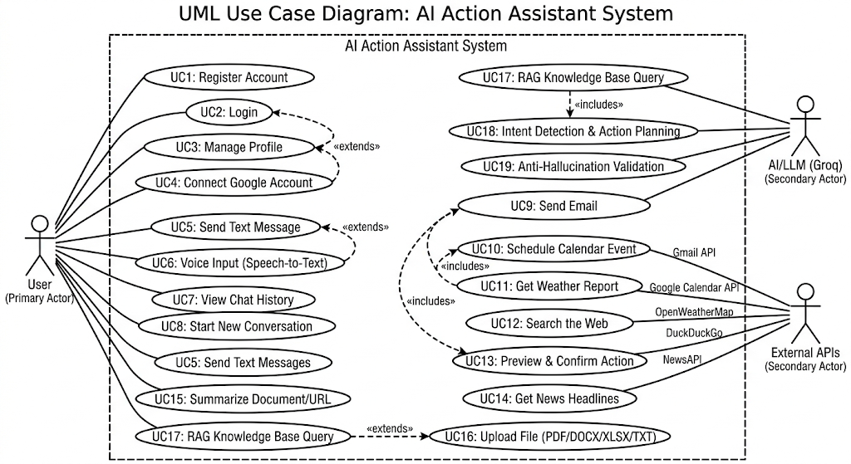
Use Case Diagrams

Figure 8-1 Use Case Diagram

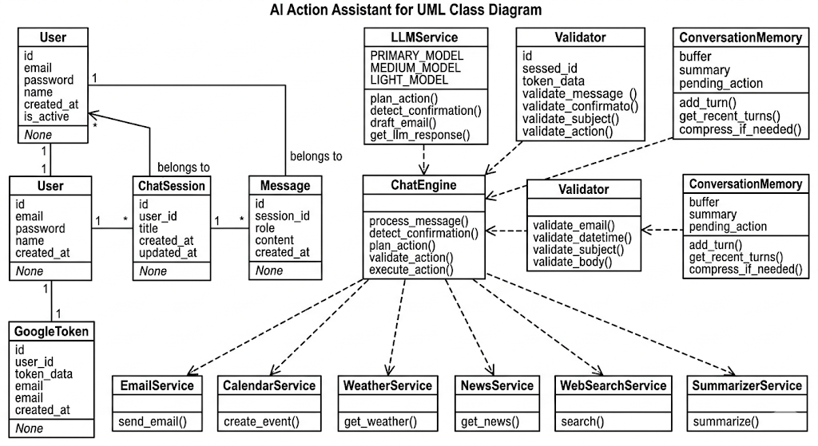
7.2 Class Diagram

Figure 8-2 Class Diagram

7.3 Sequence Diagram
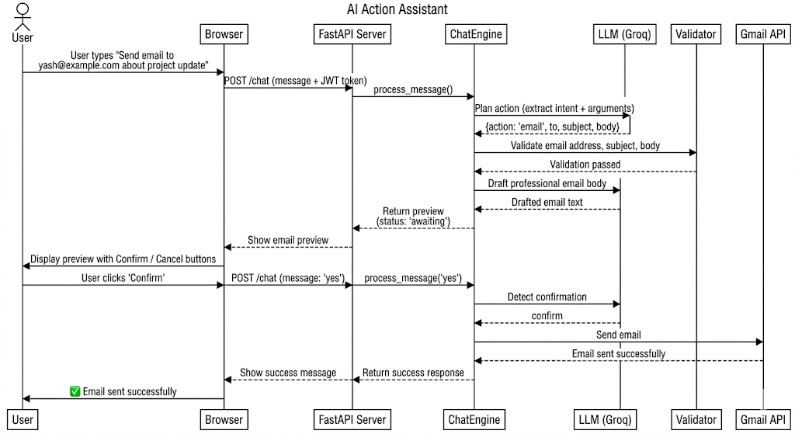

Figure 8-3 Sequence Diagram

7.4 Activity Diagram
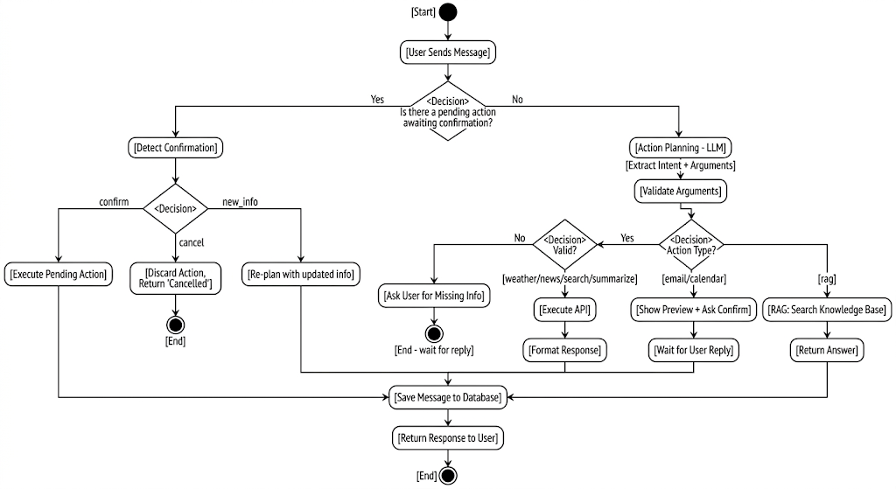

Figure 8-4 Activity Diagram

7.5 DFD (Data Flow Diagram)

7.5.1 DFD 0
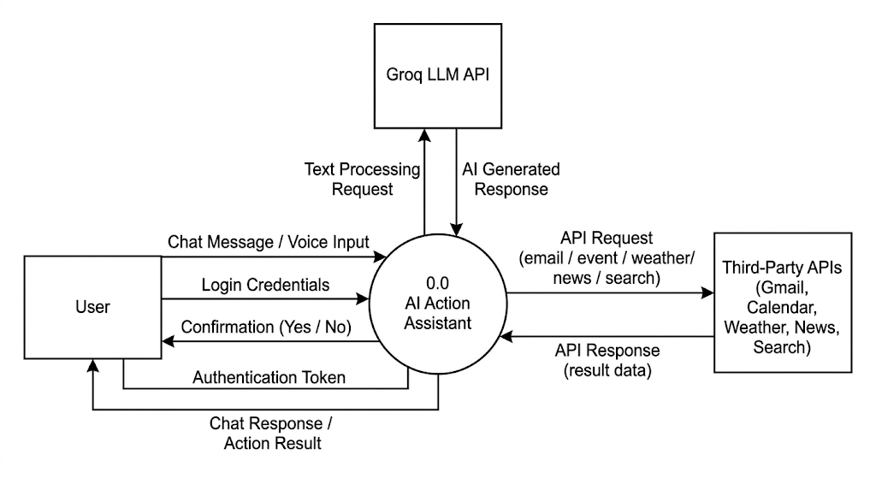
Figure 8-5 DFD-0

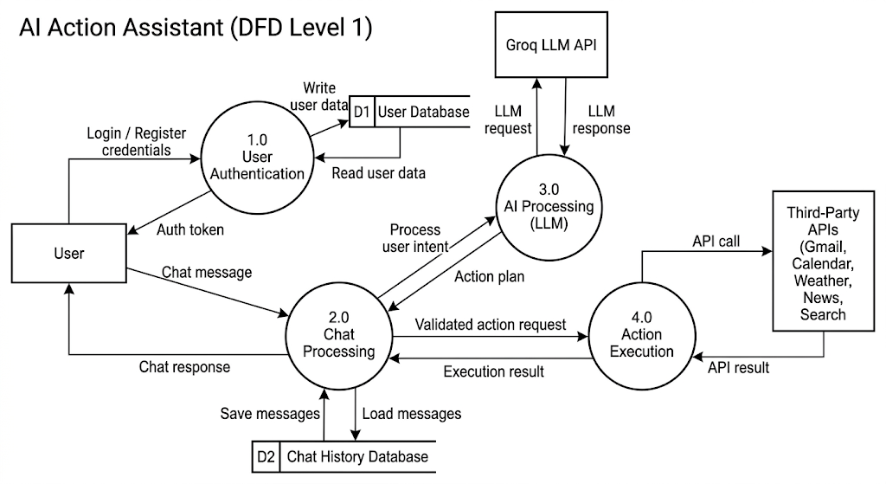
7.5.2 DFD 1

Figure 8-6 DFD-1

7.5.3 DFD 2
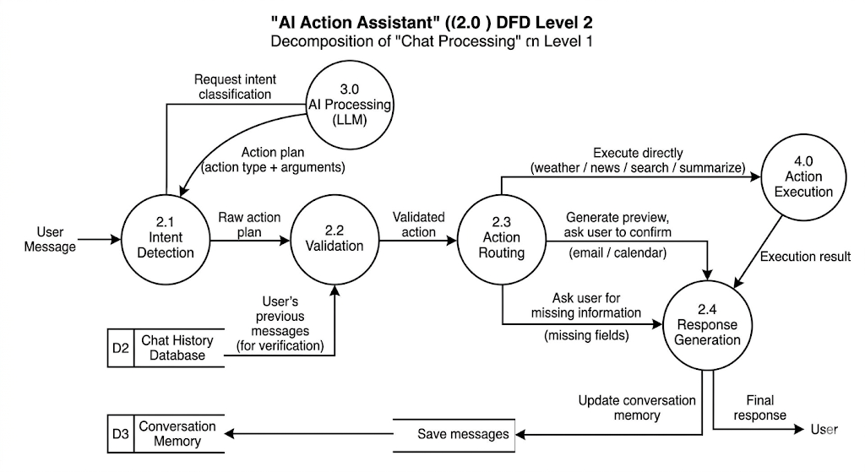

Figure 8-7 DFD-2

7.6 User Interface

- Login Interface

The Login page presents a glassmorphic sign-in card centered over an animated sky-gradient background with floating aurora blobs and particle effects. The card features the AI Action Assistant branding with the signature ✦ logo mark, email and password input fields with floating labels, and a gradient "Sign In" call-to-action button with a shimmer animation. An error notification area provides real-time feedback for invalid credentials. The page automatically redirects authenticated users to the Dashboard, ensuring a seamless session-resumption experience. A footer link navigates to the registration page for new users.

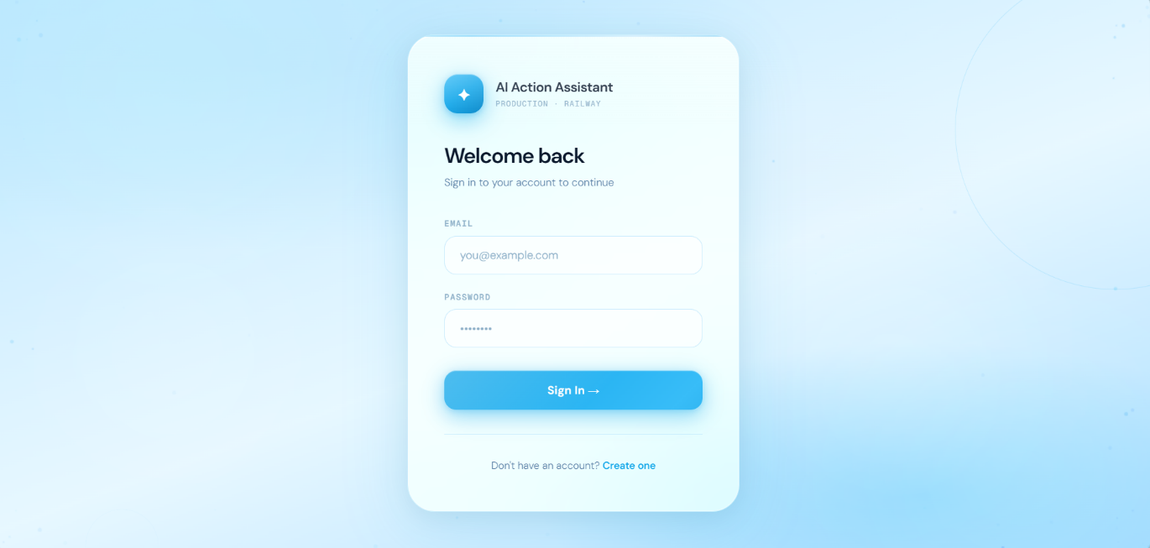

Figure 8-8 Login Page

- Registration Interface

The Sign Up page mirrors the premium glassmorphism design of the Login page, with an independently animated layered sky background and canvas-rendered sparkle particles. It presents a registration form with Full Name, Email, and Password fields — each featuring focus-responsive label highlighting and smooth transition animations. Client-side validation enforces a minimum 8-character password policy before the request is submitted. Upon successful registration, the system issues a JWT access token and redirects the user directly to the Dashboard, eliminating redundant sign-in steps. A footer link provides navigation back to the Login page for existing users.

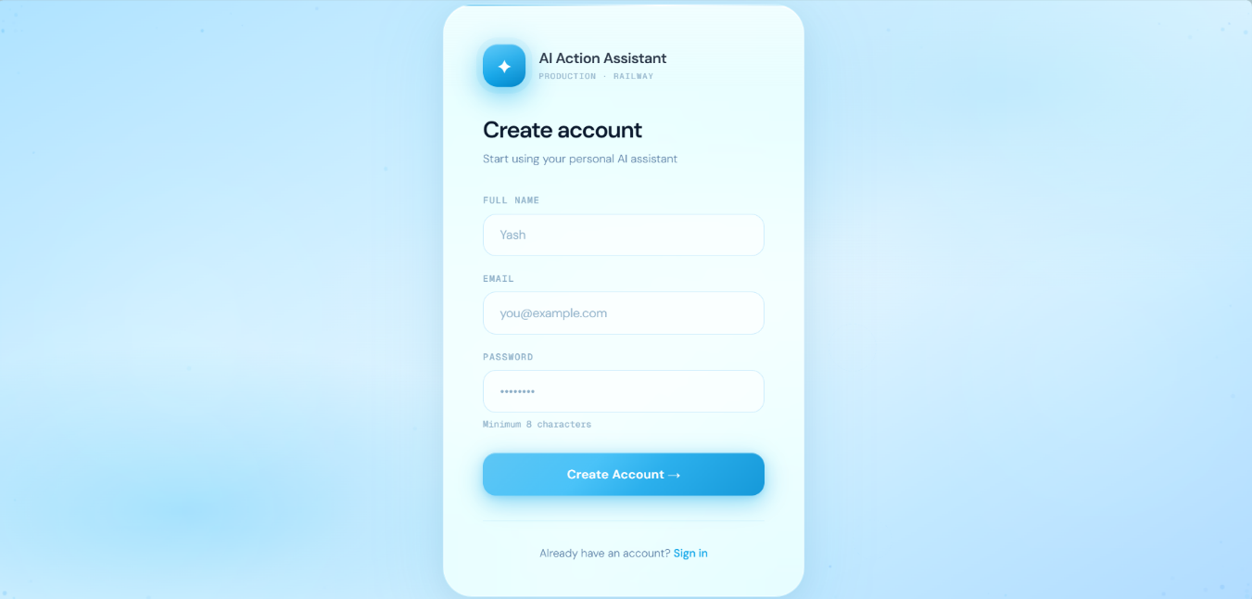

Figure 8-9 Sign Up Page

- Dashboard Interface

The Dashboard is the primary interaction hub of the AI Action Assistant, featuring a responsive two-panel layout. The left sidebar contains the application branding, a "New Conversation" button, a service-selection grid (Weather, News, Web Search, Email, Calendar, and Document Summarization), a scrollable chat history list, a real-time connection status indicator, and a user profile menu with dropdown options for Profile, About, Voice Settings, and Sign Out. The main chat area displays a welcome screen with quick-action suggestion chips, a message thread with distinct AI and user message bubbles, and a feature-rich input bar supporting text entry, file attachments (PDF, DOCX, XLSX, TXT), voice input via Groq Whisper, text-to-speech output, and contextual shortcut buttons — all rendered with a frosted-glass aesthetic, subtle micro-animations, and an ambient sky-blue color palette.

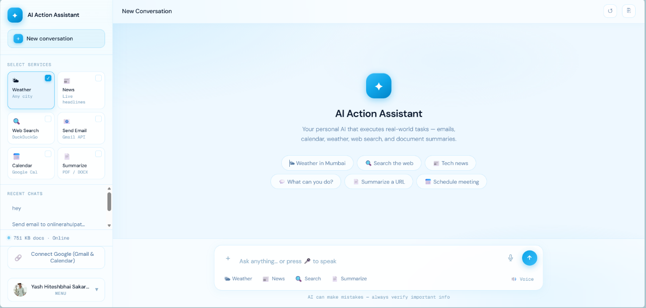

Figure 8-10 Dashboard

- Scan Results Interface
The Scan Results Interface displays the outcomes of previously executed network scans in a structured table format. It provides filtering options such as Scan Type, Status, Date Range, and Search Target, allowing users to quickly locate specific scan records.
Each entry shows important details including Target Address, Scan Type, Port Range, Scan Status, Progress, Duration, and Date. Action buttons such as View, Topology, and Delete allow users to analyze scan reports, visualize network structure, or manage stored results efficiently.
This interface helps users organize, review, and manage scanning history in a clear and user-friendly manner.

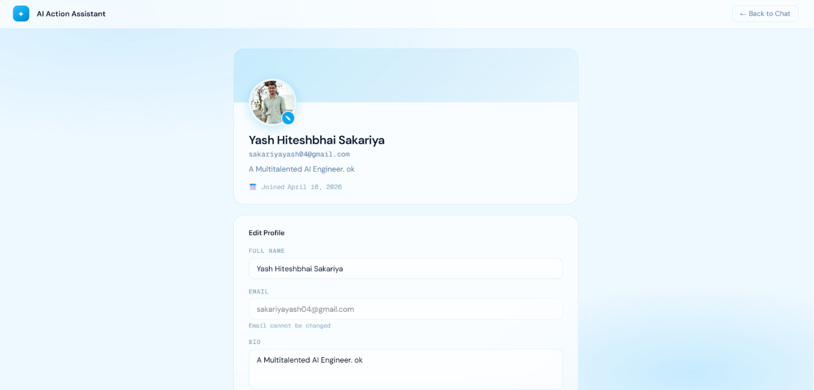

Figure 8-11 Result Page

IMPLEMENTATION DETAILS

Algorithm of Implementation

The The AI Action Assistant follows a structured algorithm to process user messages, classify intent, validate data, and execute actions. The core processing logic is implemented through the 7-step chat engine pipeline.

Algorithm: Chat Message Processing
Step 1: User sends a message via the /chat endpoint with JWT authentication.

Step 2: System checks if a pending action exists in the session (awaiting confirmation).

- If yes, classify the user's reply as confirm, cancel, or new_info using LLM.
- If confirm — execute the pending action immediately and return the result.
- If cancel — discard the pending action and notify the user.
- If new_info — re-enter the planning pipeline with updated context.

Step 3: If no pending action, send the message along with conversation history to the LLM for action planning. The LLM outputs a structured JSON plan containing the action type and extracted arguments.

Step 4: Pass all extracted arguments through the anti-hallucination validation layer.

- Verify email addresses against actual user messages using regex matching.
- Validate dates as parseable and in the future.
- Scan email bodies for LLM placeholder patterns.
- Strip any fabricated data and mark those fields as missing.

Step 5: If the action is RAG (knowledge base query), perform vector similarity search in ChromaDB, retrieve top-5 matching chunks above the similarity threshold, and synthesize an answer using LLM.

Step 6: If the action is a read-only operation (weather, news, search, summarize), execute immediately through the respective service module and return the formatted result.

Step 7: If required fields are missing for email or calendar actions, enter the multi-turn field collection loop. The LLM generates a natural language prompt asking for the specific missing field. Previously collected fields are preserved in the pending action scratchpad.

Step 8: Once all fields are collected and validated, display a full preview of the action to the user. Set the session state to awaiting_confirmation. The action executes only when the user explicitly confirms.

Step 9: Store the user message and assistant response in the database. Update conversation memory. If the memory buffer exceeds the threshold, compress older messages using LLM summarization.
Step 10: Return the response to the user with appropriate status (success, error, pending, awaiting, or cancelled

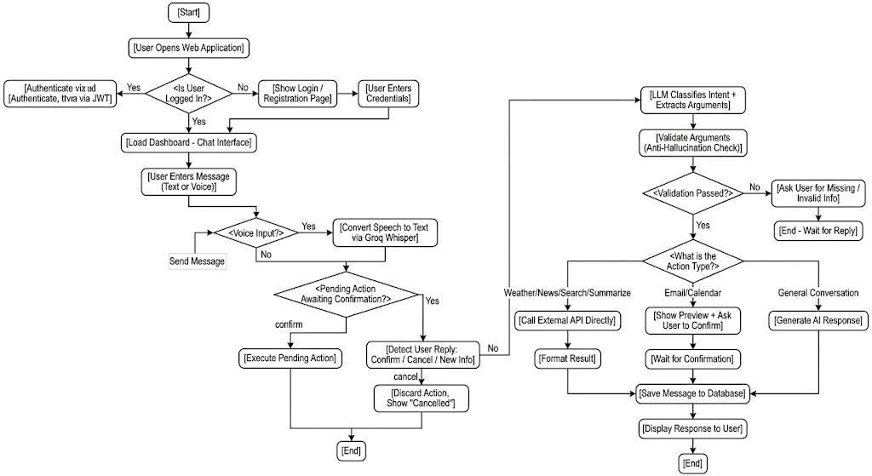
Flowchart of Implementation

Figure 9-1 Flowchart

Actual Program Code

Module 1: Chat Engine - 7-Step Processing Pipeline (backend/chat_engine.py):

def process(message: str, session: Session, file_path: str = None,
selected_services: list = None, user_id: str = None, db=None) -> ChatResponse:
memory = session.memory
selected_services = selected_services or []
all_user_messages = _get_user_messages(memory)

# 1. CONFIRMATION CHECK
if session.awaiting_confirmation and memory.pending_action:
pending_action_type = memory.pending_action.get("action", "action")
intent = detect_confirmation(message, pending_action_type)
if intent == "confirm":
session.awaiting_confirmation = False
response = _execute(memory.pending_action, user_id=user_id, db=db)
memory.clear_pending_action()
memory.add("user", message)
memory.add("assistant", response.message)
return response
if intent == "cancel":
session.awaiting_confirmation = False
memory.clear_pending_action()
msg = "No problem — action cancelled. What else can I help you with?"
memory.add("user", message)
memory.add("assistant", msg)
return _r("cancelled", "none", msg)
session.awaiting_confirmation = False

# 2. PLAN
history = memory.get_buffer()
plan = plan_action(message, history=history, selected_services=selected_services)
plan = memory.merge_action_arguments(plan)

# 3. VALIDATE
plan = validate_action(plan, user_message=message, all_user_messages=all_user_messages)
action = plan["action"]

# 4. RAG
if action == "rag":
memory.clear_pending_action()
reply = run_rag(message, memory)
return _r("success", "rag", reply)

# 5. DIRECT EXECUTION (no confirmation needed)
if action in ("news", "weather", "web_search"):
response = _execute(plan, user_id=user_id, db=db)
memory.clear_pending_action()
memory.add("user", message)
memory.add("assistant", response.message)
return response

# 6. EMAIL — auto-draft body/subject
if action == "email":
args = plan.get("arguments", {})
if args.get("recipient_name") and not args.get("body"):
args = _ensure_email_body(args, message)
plan["arguments"] = args

# 7. MISSING FIELDS
if plan["missing_fields"]:
memory.set_pending_action(plan)
prompt = generate_missing_field_prompt(
action=action, missing_fields=plan["missing_fields"],
current_args=plan.get("arguments", {}), history=history)
memory.add("user", message)
memory.add("assistant", prompt)
return _r("pending", action, prompt)

# 8. PREVIEW + CONFIRM
memory.set_pending_action(plan)
session.awaiting_confirmation = True
response = _preview(plan, message)
memory.add("user", message)
memory.add("assistant", response.message)
return response

Module 2: 3-Tier LLM Routing (core/llm_service.py):

def _call(messages: list, tier: str = "primary",
max_tokens: int = 800, temperature: float = 0.4) -> str:
from groq import RateLimitError, APIStatusError

tier_map = {
"primary": (config.GROQ_API_KEY_PRIMARY, config.GROQ_MODEL_PRIMARY),
"medium": (config.GROQ_API_KEY_MEDIUM, config.GROQ_MODEL_MEDIUM),
"light": (config.GROQ_API_KEY_LIGHT, config.GROQ_MODEL_LIGHT),
}
api_key, model = tier_map.get(tier, tier_map["primary"])

attempts = [(api_key, model)]
if tier != "primary" and api_key != config.GROQ_API_KEY_PRIMARY:
attempts.append((config.GROQ_API_KEY_PRIMARY, config.GROQ_MODEL_PRIMARY))

last_err = ""
for key, mdl in attempts:
try:
client = _get_client(key)
response = client.chat.completions.create(
model=mdl, messages=messages,
temperature=temperature, max_tokens=max_tokens)
return response.choices[0].message.content.strip()
except RateLimitError as exc:
last_err = str(exc)
continue
except APIStatusError as exc:
return f"The AI service returned an error ({exc.status_code})."

return "The AI model has hit its token limit for today."

Module 3: Anti-Hallucination Validator (core/validators.py):

_EMAIL_REGEX = re.compile(
r"^[A-Za-z0-9!#$%&'*+/=?^_`{|}~-]+"
r"(?:\.[A-Za-z0-9!#$%&'*+/=?^_`{|}~-]+)*"
r"@(?:[A-Za-z0-9](?:[A-Za-z0-9-]{0,61}[A-Za-z0-9])?\.)+[A-Za-z]{2,}$"
)

def validate_email_address(email: str, user_message: str,
all_user_messages=None) -> Tuple[bool, str]:
email = email.strip() if email else ""
if not is_valid_email_format(email):

return False, f"'{email}' is not a valid email format."

# CRITICAL: Verify email was typed by user, not fabricated by LLM
messages_to_search = [user_message]
if all_user_messages:
messages_to_search.extend(all_user_messages)

user_provided = False
for msg in messages_to_search:
if not msg:
continue
emails_in_msg = extract_emails_from_text(msg)
if email.lower() in [e.lower() for e in emails_in_msg]:
user_provided = True
break

if not user_provided:
return False, (f"Email '{email}' was not found in the user's messages. "
f"The system cannot use emails the user did not provide.")
return True, ""

def validate_email_body(body: str) -> Tuple[bool, str]:
if not body or not body.strip():
return False, "Email body cannot be empty."
if len(body.strip()) < 10:
return False, "Email body is too short to be a real message."

placeholder_patterns = [
r"\[INSERT\s", r"\[YOUR\s", r"\[FILL\s",
r"\[PLACEHOLDER", r"\[TODO", r"<INSERT\s", r"<YOUR\s",
]
for pattern in placeholder_patterns:
if re.search(pattern, body, re.IGNORECASE):
return False, "The email body contains placeholder text."
return True, ""

Module 4: RAG Pipeline (core/rag_pipeline.py):

def run_rag(query: str, memory) -> str:
knowledge_context = ""
kb_used = False

try:
query_embedding = generate_embeddings([query])[0]

kb_results = query_similar(query_embedding, top_k=5)

relevant = [r for r in kb_results if r["score"] < config.SIMILARITY_THRESHOLD]

if relevant:
knowledge_context = "\n\n".join(r["document"] for r in relevant)
kb_used = True
except Exception as exc:
log.warning("KB search failed: %s", exc)

context_parts = []
if knowledge_context:
context_parts.append("Knowledge Base:\n" + knowledge_context)
conv_context = memory.get_context_block()
if conv_context:
context_parts.append(conv_context)
context = "\n\n".join(context_parts)

system = BASE_SYSTEM_PROMPT.format(datetime=now_str)
if context:
system += "\n\nCONTEXT (use this to answer):\n" + context

msgs = [{"role": "system", "content": system}]
history = memory.get_buffer()
if history:
msgs.extend(history[-10:])
msgs.append({"role": "user", "content": query})

response = _call_primary(msgs) if kb_used else _call_light(msgs)
memory.add("user", query)
memory.add("assistant", response)
return response

Module 5: Conversation Memory Manager (core/memory_manager.py):

class ConversationMemory:
def __init__(self, max_buffer_turns: int = 10, compress_threshold: int = 30):
self.max_buffer_turns = max_buffer_turns
self.compress_threshold = compress_threshold
self._buffer: List[Dict] = []
self._summary: str = ""
self.pending_action: Optional[Dict] = None

def add(self, role: str, content: str) -> None:

self._buffer.append({"role": role, "content": content})
if (len(self._buffer) > self.max_buffer_turns * 2
and len(self._buffer) >= self.compress_threshold):
self._compress()

def _compress(self) -> None:
from core.llm_service import _call_light
half = len(self._buffer) // 2
old = self._buffer[:half]
self._buffer = self._buffer[half:]
text = "\n".join(f"{m['role'].upper()}: {m['content']}" for m in old)
prompt = [
{"role": "system", "content":
"Summarise the conversation. Preserve key decisions, "
"names, emails, dates and confirmed actions. Be brief."},
{"role": "user", "content": text},
]
try:
update = _call_light(prompt, max_tokens=200, temperature=0.0)
self._summary = (self._summary + "\n" + update).strip()
except Exception as exc:
log.warning("Compression failed: %s", exc)

def merge_action_arguments(self, new_plan: Dict) -> Dict:
if not self.pending_action:
return new_plan
pending_type = self.pending_action.get("action")
incoming_type = new_plan.get("action")
if incoming_type != "rag" and incoming_type != pending_type:
self.pending_action = new_plan
return new_plan
if incoming_type == "rag" and pending_type != "rag":
return self.pending_action
existing = dict(self.pending_action.get("arguments", {}))
for k, v in new_plan.get("arguments", {}).items():
if v is not None:
existing[k] = v
self.pending_action["arguments"] = existing
return self.pending_action

Module 6: Gmail API Integration (services/email_service.py):

def send_email(to: Union[str, List[str]], subject: str, body: str,

user_id: str = None, db=None) -> Dict:
if isinstance(to, str):
to = [to]
to = [addr.strip() for addr in to if addr.strip()]

if not to:
return {"status": "error", "message": "No recipient email provided."}
if not subject or not subject.strip():
return {"status": "error", "message": "Email subject cannot be empty."}
if not body or not body.strip():
return {"status": "error", "message": "Email body cannot be empty."}

try:
service = _get_gmail_service(user_id=user_id, db=db)
msg = MIMEMultipart("alternative")
msg["To"] = ", ".join(to)
msg["Subject"] = subject.strip()
msg["From"] = config.EMAIL_USER

msg.attach(MIMEText(body.strip(), "plain"))
html_body = body.strip().replace("\n", "<br>")
html_content = f"""<html><body>
<div style="font-family:Arial;font-size:14px;color:#333;">
{html_body}</div></body></html>"""
msg.attach(MIMEText(html_content, "html"))

raw = base64.urlsafe_b64encode(msg.as_bytes()).decode("utf-8")
sent = service.users().messages().send(
userId="me", body={"raw": raw}).execute()
return {"status": "success",
"message": f"Email sent. ID: {sent.get('id')}"}

except PermissionError as exc:
return {"status": "error", "message": str(exc)}
except Exception as exc:
return {"status": "error", "message": f"Failed to send email: {exc}"}

TESTING

Testing Approach

The system was tested using a combination of manual testing, automated tool testing, and functional validation to ensure all modules perform as expected. Each component chat engine, LLM service, anti-hallucination validators, email service, calendar service, RAG pipeline, and authentication was tested independently and then integrated for system-level testing.
Testing was conducted using the built-in terminal chat client, MCP Inspector browser UI, Swagger API documentation, and Postman for endpoint validation.

Testing Model Used

The project follows a combination of Unit Testing and Integration Testing within the Agile Incremental Model.
- Unit Testing: Individual modules such as email service, weather service, validators, and RAG pipeline were tested independently to verify their correctness.
- Integration Testing: After individual modules were validated, they were integrated and tested together to ensure proper communication between the chat engine, LLM service, validators, and external APIs.
- System Testing: The complete system was tested end-to-end — from user login through natural language input, intent classification, validation, action execution, and response display.

This approach ensured early detection of errors and continuous improvement during development.

Types of Testing Performed

The following types of testing were carried out:

- Functional Testing

- Verified all system functionalities including email sending, calendar scheduling, weather retrieval, news fetching, web search, and document summarization.
- Ensured that the 7-step chat pipeline processes messages correctly across all action types.

2. Anti-Hallucination Testing

- Verified that LLM-fabricated email addresses are rejected by the validation layer.
- Tested that past dates are blocked for calendar events.
- Confirmed that placeholder patterns in email bodies are detected and rejected.

3. Security Testing

- Verified JWT authentication blocks unauthorized access to all protected endpoints.
- Tested bcrypt password hashing for secure credential storage.
- Ensured rate limiting restricts excessive requests per session.

4. Performance Testing

- Tested system response time across all three LLM tiers.
- Evaluated RAG pipeline performance with vector similarity search.
- Verified fallback behavior when API keys hit rate limits.

5. Usability Testing

- Evaluated ease of use of the chat dashboard interface.
- Tested responsive design across desktop and mobile screen sizes.
- Verified voice input/output functionality across browsers.

Test Cases and Results

Test Case ID | Description | Input | Expected Output | Actual Output | Status
TC01 | User Registration | Valid email and password | Account created, JWT returned | Account created successfully | Pass
TC02 | Invalid Login | Wrong password | Error message | Error displayed | Pass
TC03 | Send Email | Valid recipient, subject, body | Email sent via Gmail API | Email sent successfully | Pass
TC04 | Email Hallucination Check | LLM-fabricated email address | Email stripped, user re-prompted | Fabricated email rejected | Pass
TC05 | Calendar Event Creation | Title, date, time | Event created in Google Calendar | Event created with link | Pass
TC06 | Past Date Rejection | Past date for calendar | Error message shown | Past date rejected | Pass
TC07 | Weather Retrieval | City name "Mumbai" | Weather data displayed | Temperature, humidity shown | Pass
TC08 | News Retrieval | Topic "technology" | News headlines returned | Headlines displayed | Pass
TC09 | Web Search | Query "Python FastAPI" | Search results returned | Results displayed | Pass
TC10 | Document Summarization | Uploaded PDF file | Summary generated | Summary displayed | Pass
TC11 | RAG Knowledge Query | Question about stored documents | Answer from knowledge base | Relevant answer returned | Pass
TC12 | Confirmation Gate | User confirms email preview | Email executed | Email sent after confirmation | Pass
TC13 | Action Cancellation | User cancels pending action | Action discarded | Cancellation confirmed | Pass
TC14 | Rate Limiting | 31 requests in 60 seconds | Request blocked | Rate limit enforced | Pass
TC15 | MCP Tool Execution | Weather tool via MCP Inspector | Weather data returned | Correct response | Pass
Table 10-1 Test Cases

Test Results Summary

The testing results indicate that the system performs all intended functionalities accurately and reliably. All core modules — including the chat engine, LLM routing, anti-hallucination validators, email service, calendar service, and RAG pipeline — function as expected.
The anti-hallucination layer successfully rejected all fabricated email addresses

and past dates during testing. The confirmation gate correctly prevented irreversible actions from executing without user approval. The 3-tier LLM routing distributed tasks across models as designed, with automatic fallback functioning correctly when rate limits were reached.
Overall, the system meets the functional and non-functional requirements specified in the project scope

Conclusion of Testing

The testing phase confirms that the AI Action Assistant is reliable, secure, and user-friendly. The systematic testing approach ensured early detection of critical issues such as LLM hallucination and unauthorized action execution.

The application is ready for production deployment and has been successfully deployed on the Railway cloud platform with Docker containerization.
.

USER MANUAL

About AI Action Assistant

The AI Action Assistant is a web-based AI-powered platform that allows users to execute real-world tasks through natural language commands. Users can send emails, schedule calendar events, check weather, read news, search the web, summarize documents, and query a knowledge base — all by simply typing or speaking in plain English.
The system uses a conversational chat interface where the AI interprets user intent, validates all critical data, and executes actions through authenticated APIs. For irreversible actions like sending emails or creating calendar events, a full preview is shown and execution occurs only after explicit user confirmation.

Key capabilities:
- Send real emails via Gmail
- Create Google Calendar events
- Fetch live weather and news data
- Search the internet
- Summarize uploaded documents (PDF, DOCX, XLSX, TXT)
- Answer questions from a knowledge base
- Voice input and output support
Access Points:
- Web Browser: Visit http://localhost:8000 (local) or the deployed Railway URL
- Terminal: Run python tests/test_terminal.py for command-line access
- MCP Clients: Connect via Claude Desktop or Cursor IDE using the MCP server
System Requirements:
- Any modern web browser (Chrome, Firefox, Edge)
- Internet connection for API access
- Microphone (optional, for voice input)

System Requirements

For End Users (Accessing the Application):

- Web browser: Google Chrome, Mozilla Firefox, or Microsoft Edge (latest version)
- Stable internet connection

- Microphone (optional, required only for voice input feature)
- Speaker (optional, required only for text-to-speech output)

For Developers (Running Locally):

- Operating System: Windows 10/11, Linux, or macOS
- Python 3.10 or above
- RAM: 8 GB minimum (16 GB recommended)
- Storage: 2 GB free disk space
- Internet connection for LLM and external API access
- Groq Cloud API key (free at console.groq.com)
- Google Cloud project with Gmail and Calendar APIs enabled
- NewsAPI key (free at newsapi.org)
- OpenWeatherMap API key (free at openweathermap.org)

For Production Deployment:

- Docker installed (for containerized deployment)
- Railway account (or any cloud platform supporting Docker)
- PostgreSQL database (auto-provisioned by Railway)

Hardware Requirements

- Processor: Intel Core i5 / AMD Ryzen 5 or equivalent
- RAM: 8 GB minimum (16 GB recommended)
- Storage: 2 GB free disk space
- Network: Stable internet connection
- Microphone: Optional (for voice input)
- Speaker: Optional (for text-to-speech output)
- GPU: Not required

Software Requirements

- Operating System: Windows 10/11, Linux (Ubuntu 20.04+), or macOS
- Web Browser: Google Chrome, Firefox, or Microsoft Edge (latest version)
- Python: Version 3.10 or above
- Database: SQLite (local) / PostgreSQL (production)
- Docker: Required for containerized deployment
- Git: Version 2.0+ for source code management
- API Keys: Groq Cloud, NewsAPI, OpenWeatherMap, Google Cloud (Gmail & Calendar APIs)

User Types

The AI Action Assistant supports the following user types:

- End User (Registered User)
- Creates an account via the signup page and logs in using email and password.
- Accesses the chat dashboard to interact with the AI assistant through natural language.
- Can send emails, schedule calendar events, fetch weather/news, search the web, summarize documents, and query the knowledge base.
- Must connect their Google account to use Gmail and Calendar features.
- Can manage profile, view chat history, and create multiple conversation sessions.

2. Developer / Administrator
- Sets up and configures the system locally or on a cloud platform.
- Manages API keys, environment variables, and Google OAuth credentials.
- Runs the terminal chat client and MCP test suite for testing and debugging.
- Monitors system health via the /health endpoint and Swagger API docs at /docs.

3. MCP Client User

- Accesses the assistant's capabilities through external AI tools such as Claude Desktop or Cursor IDE.
- Interacts with the system using the 9 exposed MCP tools without needing the web interface.
- Can perform all supported actions (chat, email, calendar, weather, news, search, summarize) through the MCP protocol.

Login

- Open the application in a web browser byvisiting http://localhost:8000 (local) or the deployed Railway URL.
- The Login page is displayed with the AI Action Assistant

branding and a dark-themed card layout.

- Enter your registered Email Address and Password in the respective fields.
- Click the "Sign In" button.
- On successful login, a JWT token is stored in the browser's localStorage and the user is automatically redirected to the Dashboard page.
- If the credentials are incorrect, a red error banner is displayed with the appropriate error message.
- If the user does not have an account, click the "Don't have an account?

“Create one" link at the bottom to navigate to the Signup page.

Note: If a valid JWT token already exists in localStorage (i.e., the user is already logged in), the Login page automatically redirects to the Dashboard without requiring re-authentication. The token expires after 72 hours, after which the user must log in again.

User Portal Guide

The After logging in, the user is directed to the Dashboard — the main interface of the AI Action Assistant. The dashboard is divided into two sections: the Sidebar and the Chat Area.

Sidebar:
- New Conversation: Click to start a fresh chat session. Previous sessions are preserved in the chat history list.
- Service Selector: Six toggleable chips — Weather, News, Search, Email, Calendar, and Summarize. Select a service to hint the AI towards a specific action.
- Chat History: A scrollable list of previous conversations. Click any session to load it. Hover to reveal the delete button.
- Connect Google: Click to link your Google account for Gmail and Calendar access. Status shows "Connected" or "Not Connected."
- System Status: Displays connection status and the active LLM model name.

Chat Area:

- Message Input: Type your command in the text area and press Enter to send. Use Shift+Enter for a new line.
- File Upload: Click the "+" button or drag-and-drop a file (PDF, DOCX, XLSX, TXT) to attach it for summarization.

- Voice Input: Click the microphone button to speak your command. The audio is transcribed via Whisper and sent as text.

- Voice Output: Click the speaker icon on any AI response to hear it read aloud.
- Quick Actions: Use the toolbar chips (Weather, News, Search, Summarize) for one-click common queries.

Using the Assistant:

- To send an email: Type something like "Send an email to john@example.com about the project update"
- To schedule an event: Type "Schedule a meeting on Friday at 3pm"
- To check weather: Type "What's the weather in Mumbai?"
- To get news: Type "Latest technology news"
- To summarize a file: Attach a PDF and type "Summarize this document"

Confirmation Flow: For email and calendar actions, the AI displays a full preview. Type "yes" to confirm and execute, or "no" to cancel. The action is never executed without your explicit approval.

Copy and History: Hover over any message to reveal a copy button. All conversations are saved per session and persist across browser refreshes.

Network Scanning and Analysis Features

- Email Sending Type a command like "Send an email to name@example.com about the meeting agenda." The AI drafts the subject and body, shows a preview, and sends only after you confirm.

- Calendar Scheduling Type "Schedule a team meeting on Monday at 2pm for 2 hours." The AI extracts the title, date, time, and duration, shows a preview with reminders, and creates the event after confirmation.

- Weather Data Type "Weather in Delhi" to get current temperature, humidity, wind speed, and conditions for any city worldwide.

- News Retrieval Type "Latest sports news" or "News about artificial intelligence" to get real-time headlines. If no news is found, the system automatically falls back to web search results.

- Web Search Type "Search for Python FastAPI tutorial" to get internet search results from DuckDuckGo with Wikipedia as a fallback source.

- Document Summarization Attach a PDF, DOCX, XLSX, or TXT file using the "+" button or drag-and-drop, then type "Summarize this

- document." The AI extracts the text and generates a concise summary. URL-based summarization is also supported.

- Knowledge Base (RAG) Ask general questions like "Tell me about Srinivasa Ramanujan" and the system searches the vector database for relevant documents. If matching content is found, the AI answers using that context.

- Voice Input Click the microphone icon, speak your command, and the audio is transcribed using Groq Whisper API and processed as a text message.

- Voice Output Click the speaker icon on any AI response to hear it read aloud using the browser's built-in text-to-speech.

10. Conversation Management Click "New Conversation" to start a fresh session. Previous sessions are listed in the sidebar and can be loaded or deleted at any time.

Troubleshooting
"Token limit reached" or AI not responding: The LLM API has hit its daily token quota. Wait for the limit to reset or add additional API keys (GROQ_API_KEY_MEDIUM, GROQ_API_KEY_LIGHT) in the .env file.
Email sending fails: Ensure your Google account is connected via the "Connect Google" button in the sidebar. If using local setup, verify that token.pickle exists and has Gmail permissions. Re-run python scripts/calendar_auth.py to re-authorize.
Calendar event not created: Check that the Google Calendar API is enabled in your Google Cloud Console. Ensure the date provided is in the future — past dates are rejected by the validation layer.
"Email not found in user messages" error: The anti-hallucination system detected that the email address was fabricated by the LLM. Provide the recipient's email address explicitly in your message.
Login fails or redirects to login page repeatedly: The JWT token may have expired (72-hour expiry). Clear localStorage in the browser and log in again.

Weather or news not loading: Verify that the OPENWEATHER_API_KEY and NEWS_API_KEY are correctly set in the .env file. Check internet connectivity.
File upload fails: Ensure the file is under 10 MB and is one of the supported formats: PDF, DOCX, XLSX, or TXT.
Voice input not working: Ensure the browser has microphone permission enabled. Voice input requires a stable internet connection for Whisper API transcription.
Server not starting: Run pip install -r requirements.txt to ensure all dependencies are installed. Verify that the .env file exists with at least GROQ_API_KEY_PRIMARYconfigured

CONCLUSION & FUTURE WORK

Conclusion

The AI Action Assistant was successfully designed, developed, and deployed as a production-grade agentic AI system capable of executing real-world tasks through natural language commands. The system addresses the key limitations of existing AI chatbots by enforcing a strict separation between LLM reasoning and Python-based action execution.

The 7-step chat processing pipeline ensures that every user message is systematically classified, validated, and executed with appropriate safeguards. The anti-hallucination validation layer prevents fabricated email addresses and dates from reaching external APIs — a critical safety feature absent in most existing solutions. The confirmation gate architecture ensures that no irreversible action is executed without explicit user approval.

The 3-tier LLM model routing architecture optimizes both cost and performance by distributing tasks across models of varying capacity, maximizing free-tier token budgets. The RAG pipeline enables the system to answer questions grounded in custom document collections, reducing reliance on potentially outdated training data.

The system integrates with six external services — Gmail, Google Calendar, NewsAPI, OpenWeatherMap, DuckDuckGo, and ChromaDB — providing a unified conversational interface for diverse tasks. The MCP server extends the system's reach beyond its own UI, enabling interoperability with Claude Desktop, Cursor IDE, and any MCP-compatible client.

Through nine complete architectural rebuilds, the project evolved from a basic chatbot wrapper into a robust, deployable platform — demonstrating that agentic AI systems can be built with strong safety guarantees while remaining practical and user-friendly.

Future Work

Although The following enhancements are planned for future development:

- Agent Orchestrator Layer: Implement a multi-agent architecture where specialized agents handle different task domains, coordinated by a central
orchestrator for complex multi-step workflows.
- Streaming Responses (SSE): Add Server-Sent Events to stream LLM responses in real-time, providing a more responsive chat experience instead of waiting for complete responses.
- Redis Session Store: Replace in-memory session caching with Redis for persistent, distributed session management across multiple server instances.
- Multi-User Google OAuth: Extend the per-user Google OAuth system to support multiple Google accounts per user and organization-level access management.

- Tool Framework with BaseTool: Introduce a plugin-based tool system where new services can be added by implementing a standardized BaseTool interface, without modifying the core chat engine.
- Mobile Application: Develop a native mobile app for Android and iOS to provide a dedicated mobile experience with push notifications for calendar reminders and email confirmations.
- Advanced RAG Pipeline: Enhance the RAG system with support for larger document collections, hybrid search (keyword + vector), document chunking strategies, and source citation in responses.
- Multi-Language Support: Add support for processing and responding in multiple languages beyond English.
- Task Scheduling and Automation: Enable users to schedule recurring tasks such as daily weather reports, weekly news summaries, or automated email reminder

ANNEXURE

Glossary of Terms and Abbreviations

- AI - Artificial Intelligence
- API — Application Programming Interface
- ASGI — Asynchronous Server Gateway Interface
- bcrypt — A password hashing algorithm based on the Blowfish cipher
- CORS — Cross-Origin Resource Sharing
- CRUD — Create, Read, Update, Delete
- CSS — Cascading Style Sheets
- DB — Database
- Docker — A platform for building and deploying containerized applications
- FastAPI — A high-performance Python web framework for building APIs
- HNSW — Hierarchical Navigable Small World (vector indexing algorithm)
- HTML — HyperText Markup Language
- HTTP — HyperText Transfer Protocol
- JWT — JSON Web Token (stateless authentication mechanism)
- LLM — Large Language Model
- MCP — Model Context Protocol (Anthropic's open protocol for AI tool integration)
- NLP — Natural Language Processing
- OAuth2 — Open Authorization 2.0 (authentication protocol)
- ORM — Object Relational Mapper
- PDF — Portable Document Format
- RAG — Retrieval Augmented Generation
- REST — Representational State Transfer
- RFC — Request for Comments (internet standard document)
- SQL — Structured Query Language
- SRS — Software Requirements Specification
- SSE — Server-Sent Events
- STT — Speech-to-Text
- TTS — Text-to-Speech
- UI — User Interface
- URL — Uniform Resource Locator
- UUID — Universally Unique Identifier
- UX — User Experience
- WBS — Work Breakdown Structure

References

- Vaswani, A., et al. (2017). "Attention Is All You Need." Advances in Neural Information Processing Systems (NeurIPS), 30. Available at: https://arxiv.org/abs/1706.03762
- Lewis, P., et al. (2020). "Retrieval-Augmented Generation for Knowledge-Intensive NLP Tasks." Advances in Neural Information Processing Systems (NeurIPS), 33. Available at: https://arxiv.org/abs/2005.11401
- Touvron, H., et al. (2023). "LLaMA: Open and Efficient Foundation Language Models." Meta AI Research. Available at: https://arxiv.org/abs/2302.13971
- Anthropic. (2024). "Model Context Protocol (MCP) — Specification." Available at: https://modelcontextprotocol.io
- FastAPI Official Documentation. Available at: https://fastapi.tiangolo.com
- Groq Cloud API Documentation. Available at: https://console.groq.com/docs

- ChromaDB Documentation. Available

at: https://docs.trychroma.com
- Sentence Transformers Documentation — all-MiniLM-L6-v2. Available at: https://www.sbert.net
- Google Gmail API Documentation. Available at: https://developers.google.com/gmail/api
- Google Calendar API Documentation. Available at: https://developers.google.com/calendar/api
- OpenWeatherMap API Documentation. Available at: https://openweathermap.org/api
- NewsAPI Documentation. Available at: https://newsapi.org/docs
- SQLAlchemy ORM Documentation. Available at: https://docs.sqlalchemy.org
- Docker Official Documentation. Available at: https://docs.docker.com
- Railway Deployment Platform. Available at: https://railway.app/docs
- OpenAI Whisper — Speech Recognition Model. Available at: https://github.com/openai/whisper
- Ji, Z., et al. (2023). "Survey of Hallucination in Natural Language Generation." ACM Computing Surveys, 55(12). Available at: https://arxiv.org/abs/2202.03629
- Python Official Documentation, Version 3.11. Available at: https://docs.python.org/3.11

About Tools and Technology
Python 3.11 A high-level, general-purpose programming language widely used in AI, machine learning, and web development. Chosen for its extensive library ecosystem and native async support.

FastAPI A modern, high-performance Python web framework for building RESTful APIs. It provides automatic request validation, interactive API documentation (Swagger UI), and native asynchronous request handling.

Groq Cloud API A cloud-hosted LLM inference platform offering ultra-low latency access to models like LLaMA 3.3 70B and LLaMA 3.1 8B. Provides free-tier access with daily token budgets.

ChromaDB An open-source vector database designed for AI applications. It stores document embeddings and supports fast cosine similarity search using HNSW indexing for the RAG pipeline.

Sentence Transformers A Python library for generating dense vector embeddings from text. The all-MiniLM-L6-v2 model produces 384-

dimensional embeddings optimized for semantic similarity tasks.

SQLAlchemy A Python ORM that provides a database-agnostic abstraction layer. It enables seamless switching between SQLite (development) and PostgreSQL (production) without code changes.

Gmail API & Google Calendar API Google's official REST APIs for sending emails and managing calendar events programmatically via OAuth2 authentication.

NewsAPI A REST API service that provides real-time news headlines and articles from sources worldwide, searchable by topic, category, or keyword.

OpenWeatherMap API A weather data API providing current weather conditions including temperature, humidity, wind speed, and visibility for any city globally.

DuckDuckGo Search (ddgs) A Python library for performing web searches via DuckDuckGo without requiring an API key. Wikipedia API serves as a fallback search strategy.

JWT (JSON Web Tokens) A compact, URL-safe token format used for stateless authentication. Implemented using the python-jose library with HS256 signing algorithm.

bcrypt A password hashing algorithm that generates one-way hashes with auto-generated salts, providing resistance against brute-force and rainbow table attacks.

Docker A containerization platform that packages the application and all dependencies into a portable container, ensuring consistent execution across different environments.

Railway A cloud deployment platform that provides automatic GitHub-based CI/CD, managed PostgreSQL databases, and HTTPS endpoints for production hosting.

FastMCP A Python library implementing the Model Context Protocol (MCP), enabling AI tools and services to be exposed to external clients like Claude Desktop and Cursor IDE.

Groq Whisper API A cloud-hosted speech-to-text service using the Whisper large-v3-turbo model for fast and accurate audio transcription.

About The Organization


- Overview of the Organization

Infopulse Technology (InfoPulseTech) is an IT solutions and services company based in Ahmedabad, Gujarat, India. The organization specializes in delivering end-to-end technology solutions, helping businesses transform their ideas into reality through strategic planning, innovative development, and sustainable execution.
Company Overview
Detail | Information
Company Name | Infopulse Technology (InfoPulseTech)
Industry | Information Technology (IT Services & Consulting)
Location | 519, iSquare Corporate Park, Science City Road, Sola, Ahmedabad, Gujarat – 380059, India
Website | infopulsetech.com

Core Services:
Infopulse Technology offers a comprehensive suite of IT services, including:
- Responsive Web Development – Building modern, responsive, and scalable web applications tailored to client business needs.
- Mobile App Development – Designing and developing cross-platform and native mobile applications.
- UI/UX Designing – Crafting intuitive, user-centric interfaces that revolutionize the user experience.
- Quality Assurance (QA) – Ensuring software reliability, performance, and security through rigorous testing practices.
- IT Consulting & Strategic Solutions – Providing businesses with technology consulting to drive growth and competitive advantage.

Mission & Vision:
InfoPulseTech is committed to "Creating a Better Tech Solution" by turning innovative ideas into reality. The organization focuses on delivering tailored solutions for business growth, executing projects from inception to completion with efficiency and precision. Their dedicated team ensures a seamless workflow, innovative strategies, and sustainable results for long-term client success.

Why InfoPulseTech:

- Diverse Technical Expertise – Wide technical proficiency across multiple fields with a range of skills and knowledge for tackling challenges and finding innovative solutions.
- Creativity & Innovation – Constantly promoting new ideas, products, and technologies that help businesses stay competitive and meet future market demands.
- Strong Customer Service – Committed to providing helpful, consistent, and satisfactory assistance to clients.
- End-to-End Execution – Complete project ownership from start to finish, ensuring efficiency, security, and scalability.


About College

- Overview of the College
U. V. Patel College of Engineering (UVPCE) is a premier engineering institute located within the campus of Ganpat University, in Kherva, Mehsana district, Gujarat, India. The college was established with the objective of providing quality technical education and developing skilled professionals capable of meeting the demands of modern industries and technological advancements.
UVPCE offers undergraduate engineering programs in several disciplines including Computer Engineering, Information Technology, Computer Science and Engineering, Artificial Intelligence, and other emerging technological fields. The institute focuses on providing a strong academic foundation along with practical knowledge and industry-oriented training.

- Vision and Mission
The vision of UVPCE is to become a leading institution in engineering education by fostering innovation, research, and technical excellence. The college aims to produce competent engineers who can contribute effectively to technological development and societal progress.
The mission of the institute is to provide high-quality education, encourage research and innovation, and develop ethical and responsible professionals who can address real-world engineering challenges.

- Academic Programs
UVPCE offers a variety of undergraduate engineering programs designed to equip students with both theoretical knowledge and practical skills. These

programs emphasize modern technologies, project-based learning, and industry exposure.The curriculum is regularly updated to incorporate advancements in fields such as computer science, information technology,

artificial intelligence, cybersecurity, and data science.

- Infrastructure and Facilities
The college provides modern infrastructure and facilities to support academic learning and research activities. The campus includes well-equipped laboratories, computer centers, classrooms, seminar halls, and library facilities. The laboratories are designed to provide hands-on experience in various engineering subjects and technologies.
The college also provides internet-enabled computer labs, research facilities, and collaborative learning environments that help students gain practical knowledge and technical expertise.

- Industry Interaction and Training
UVPCE emphasizes industry interaction and practical exposure for students. The college encourages students to participate in internships, industrial training, workshops, seminars, and technical events. These activities help students understand real-world applications of engineering concepts and prepare them for professional careers.
The institute also promotes innovation and project-based learning through final-year projects, research activities, and collaboration with industry experts.

- Contribution to Technical Education
Over the years, UVPCE has played an important role in providing quality technical education and producing skilled engineering graduates. Through its strong focus on academic excellence, research, and industry collaboration, the institute continues to contribute to the development of competent engineers and technological innovation.

